Project Milestone 2

Create an end to end CI/CD pipeline in AWS platform using Jenkins as the orchestration tool, Github as the SCM, Maven as the Build tool, Deploy in a docker instance and create a Docker image, Store the docker image in ECR, Achieve Kubernetes deployment using the ECR image. Build a sample java web app using maven.

**Tools and Their Roles**

1. **GitHub**:
   * **Version Control**: GitHub is used to host the source code repository. It tracks changes to the code, allowing multiple developers to collaborate and manage versions of the project.
2. **Jenkins**:
   * **Continuous Integration/Continuous Deployment (CI/CD)**: Jenkins automates the process of building, testing, and deploying the application. It pulls the latest code from GitHub, builds it using Maven, and deploys it to Tomcat, Docker, or Kubernetes.
3. **Maven**:
   * **Build Automation**: Maven is used to manage project dependencies and build the project. It compiles the code, runs tests, and packages the application into a deployable format (e.g., a WAR file).
4. **Tomcat**:
   * **Application Server**: Tomcat is used to deploy and run Java applications. In this project, Jenkins deploys the built application to Tomcat for testing and production use.
5. **Docker**:
   * **Containerization**: Docker is used to create container images of the application. Containers ensure that the application runs consistently across different environments by packaging the application with all its dependencies.
6. **Kubernetes (EKS)**:
   * **Orchestration**: Kubernetes manages the deployment, scaling, and operation of containerized applications. It ensures high availability and scalability by orchestrating Docker containers across a cluster of machines.

**Processes Involved**

1. **Orchestration**:
   * **Kubernetes** handles the orchestration of Docker containers. It manages the deployment of containers, ensures they are running correctly, and scales them based on demand. Kubernetes also handles load balancing and service discovery.
2. **Image Generation**:
   * **Docker** is responsible for creating container images. A Dockerfile is used to define the environment and dependencies required for the application. Jenkins builds the Docker image and pushes it to a container registry.
3. **Continuous Integration (CI)**:
   * **Jenkins** automates the process of integrating code changes. Whenever code is pushed to GitHub, Jenkins pulls the latest code, builds it using Maven, and runs tests to ensure the code is working as expected.
4. **Continuous Deployment (CD)**:
   * **Jenkins** also handles the deployment of the application. After a successful build, Jenkins deploys the application to Tomcat, Docker, or Kubernetes. This ensures that the latest version of the application is always available in the desired environment.

**Workflow Summary**

1. **Code Commit**: Developers push code changes to GitHub.
2. **CI Pipeline**: Jenkins pulls the latest code, builds it using Maven, and runs tests.
3. **Image Creation**: Jenkins uses Docker to create a container image of the application.
4. **Deployment**: Jenkins deploys the application to Tomcat, Docker, or Kubernetes.
5. **Orchestration**: Kubernetes manages the deployment and scaling of Docker containers.

**Task 1:**

* Create an instance

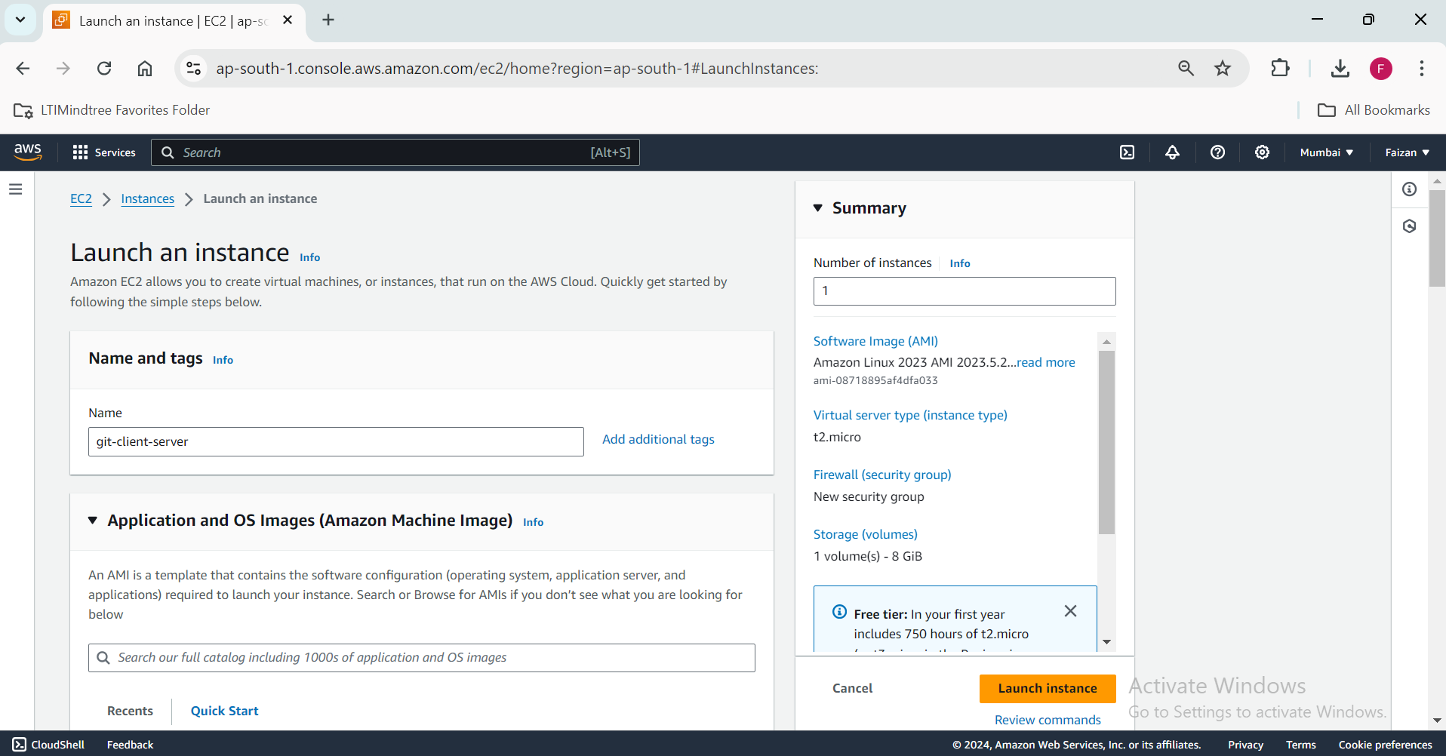

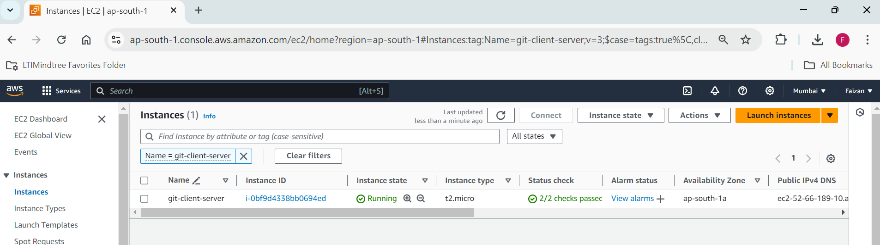

* Install git

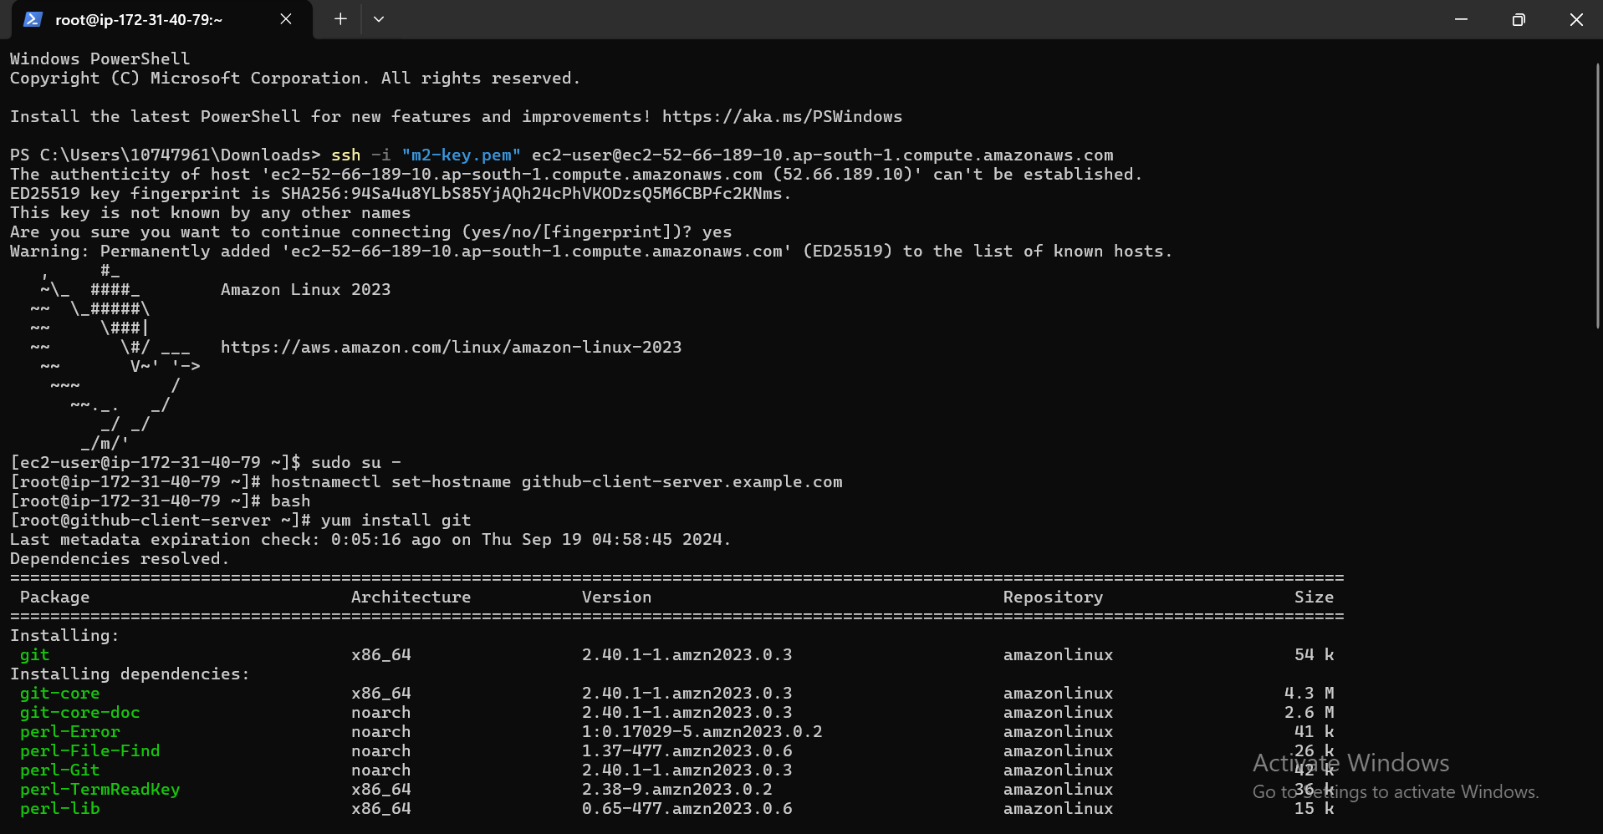

Cloning the java file

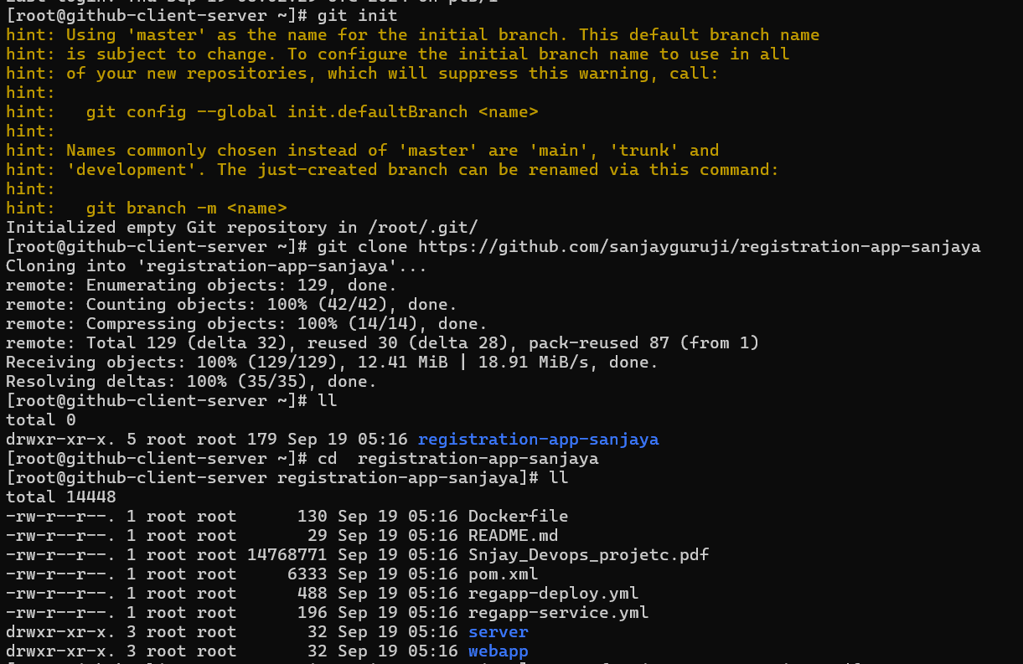

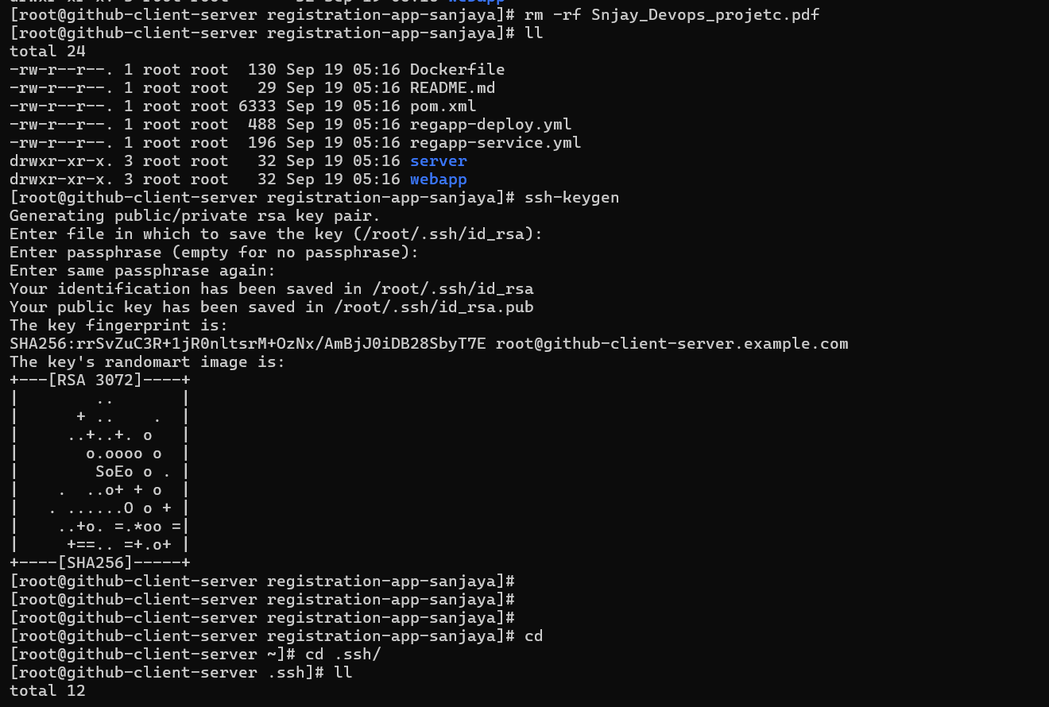

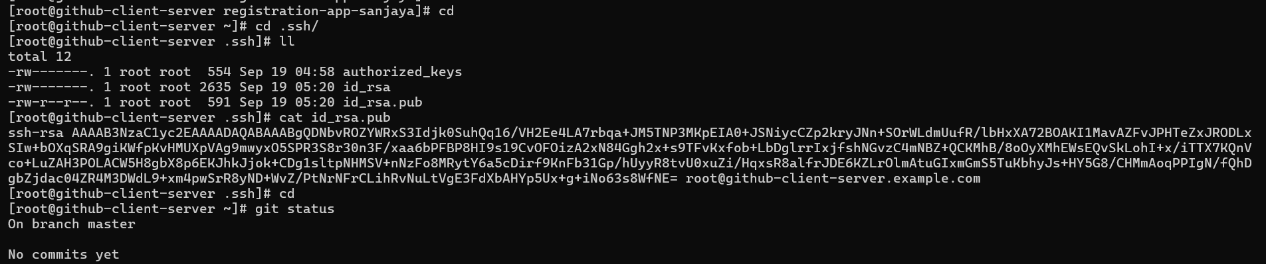

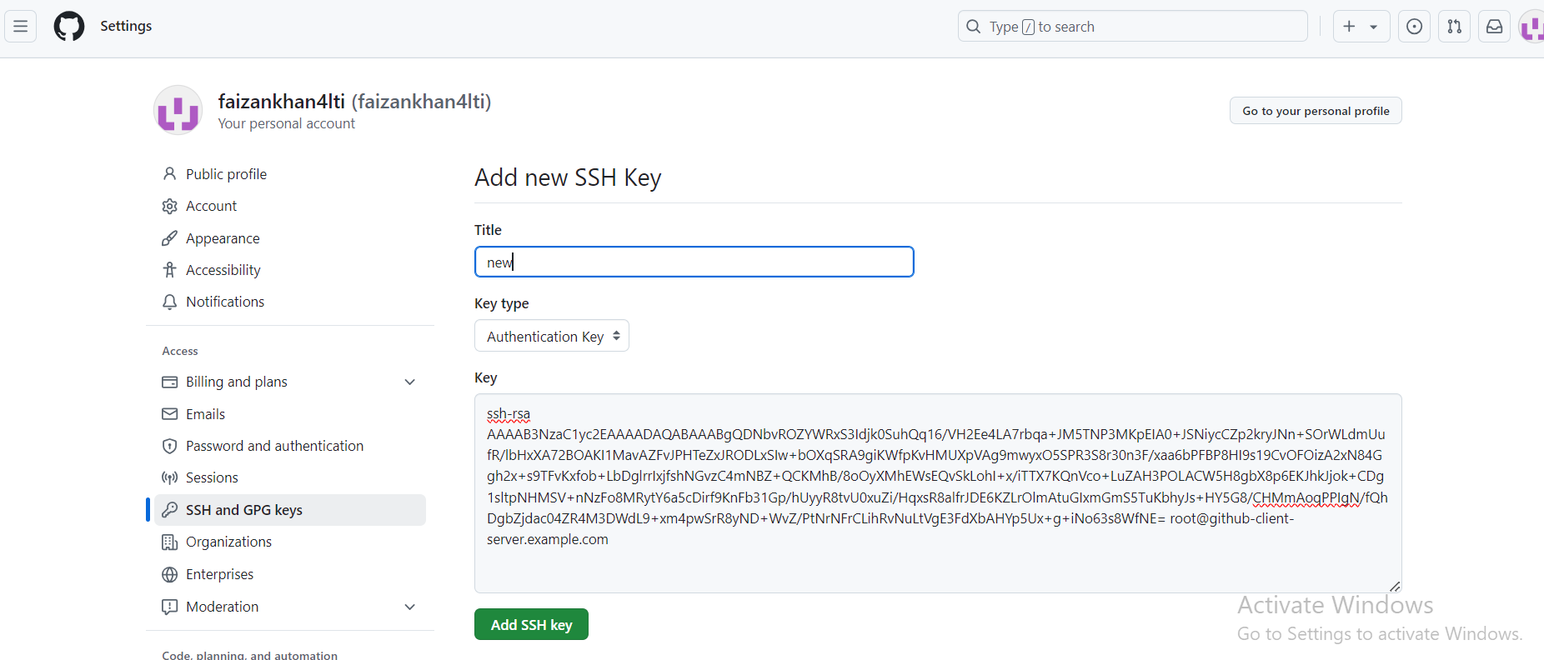



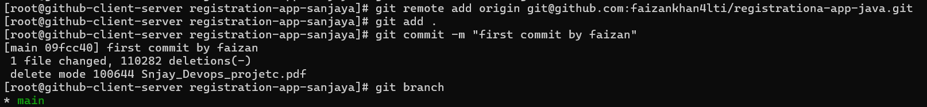

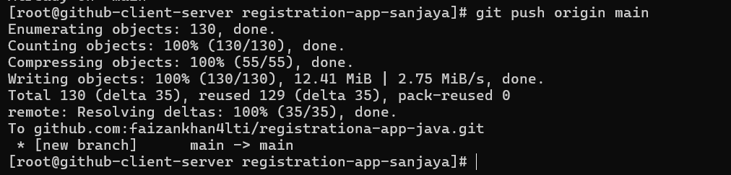

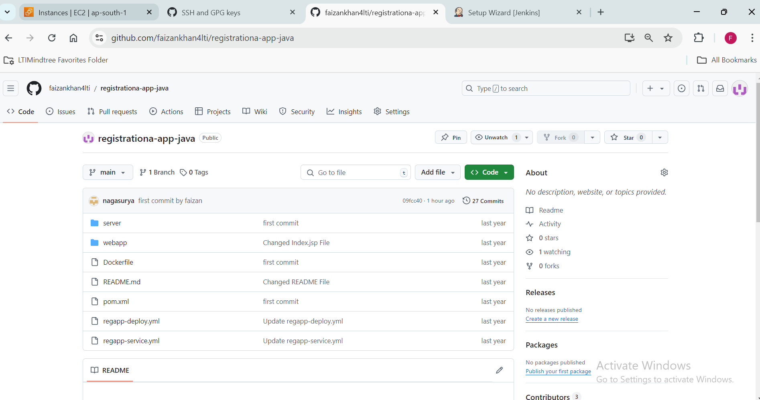

**Task-2:**

Creating a Jenkins server:

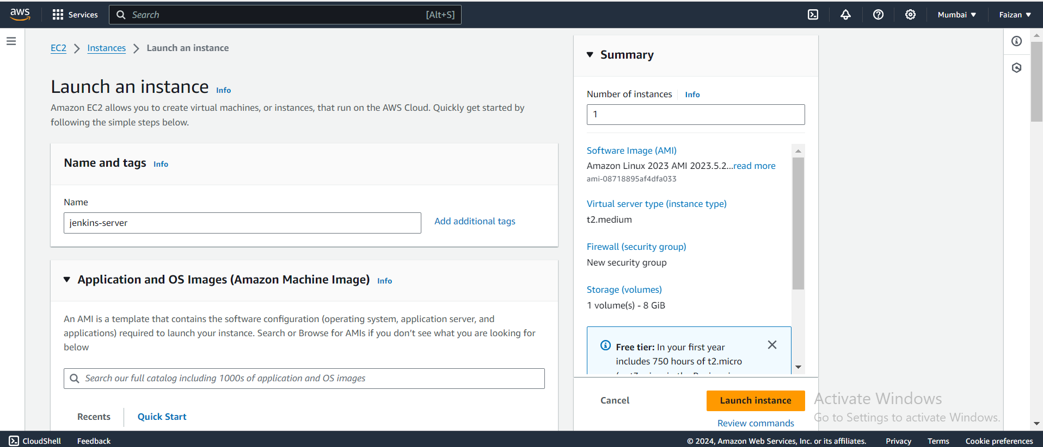

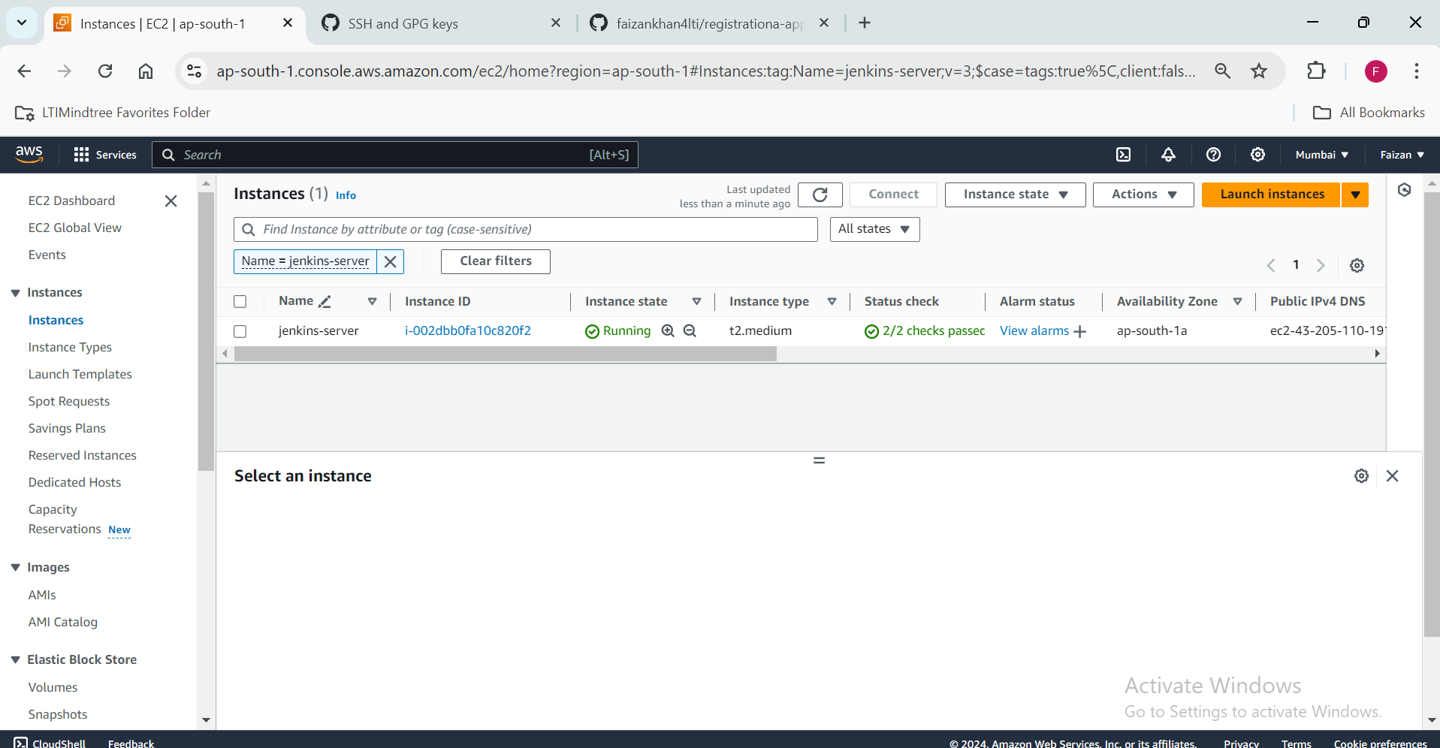

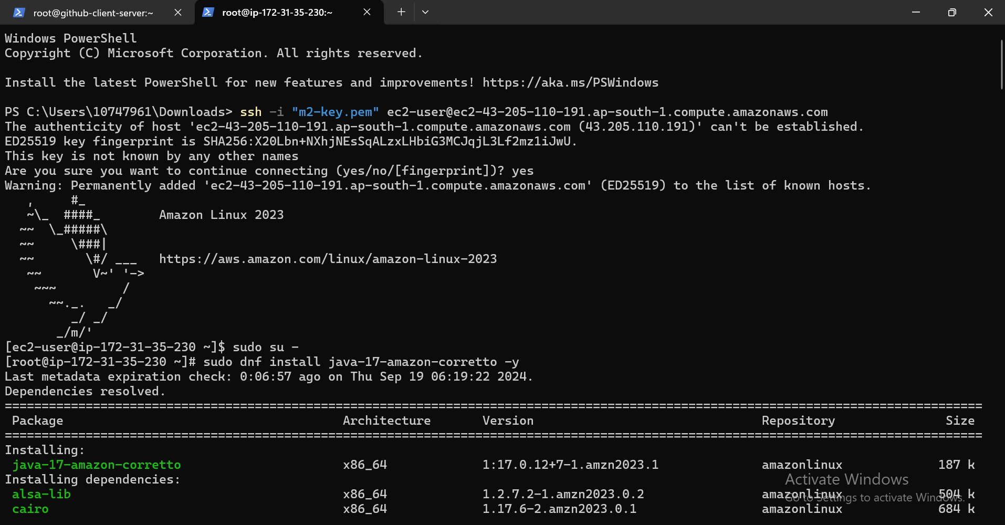

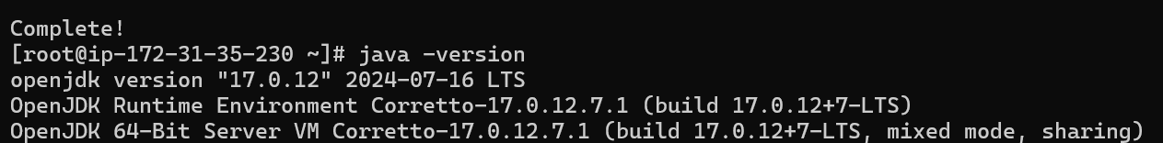

Allowing Custom TCP at port 8080:

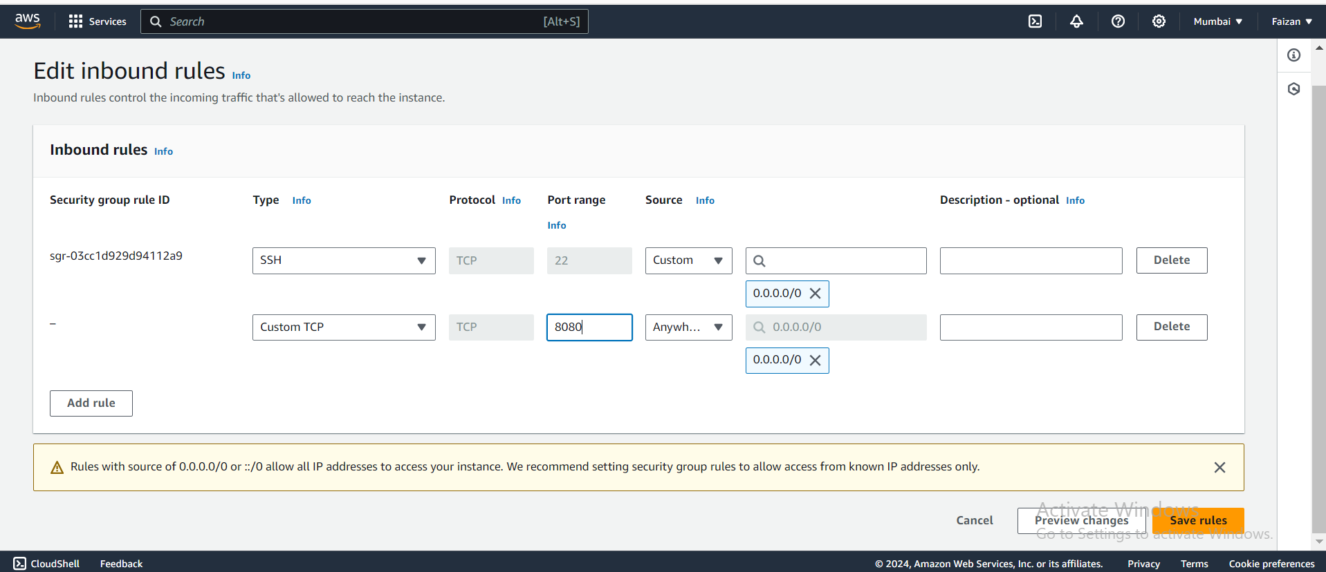

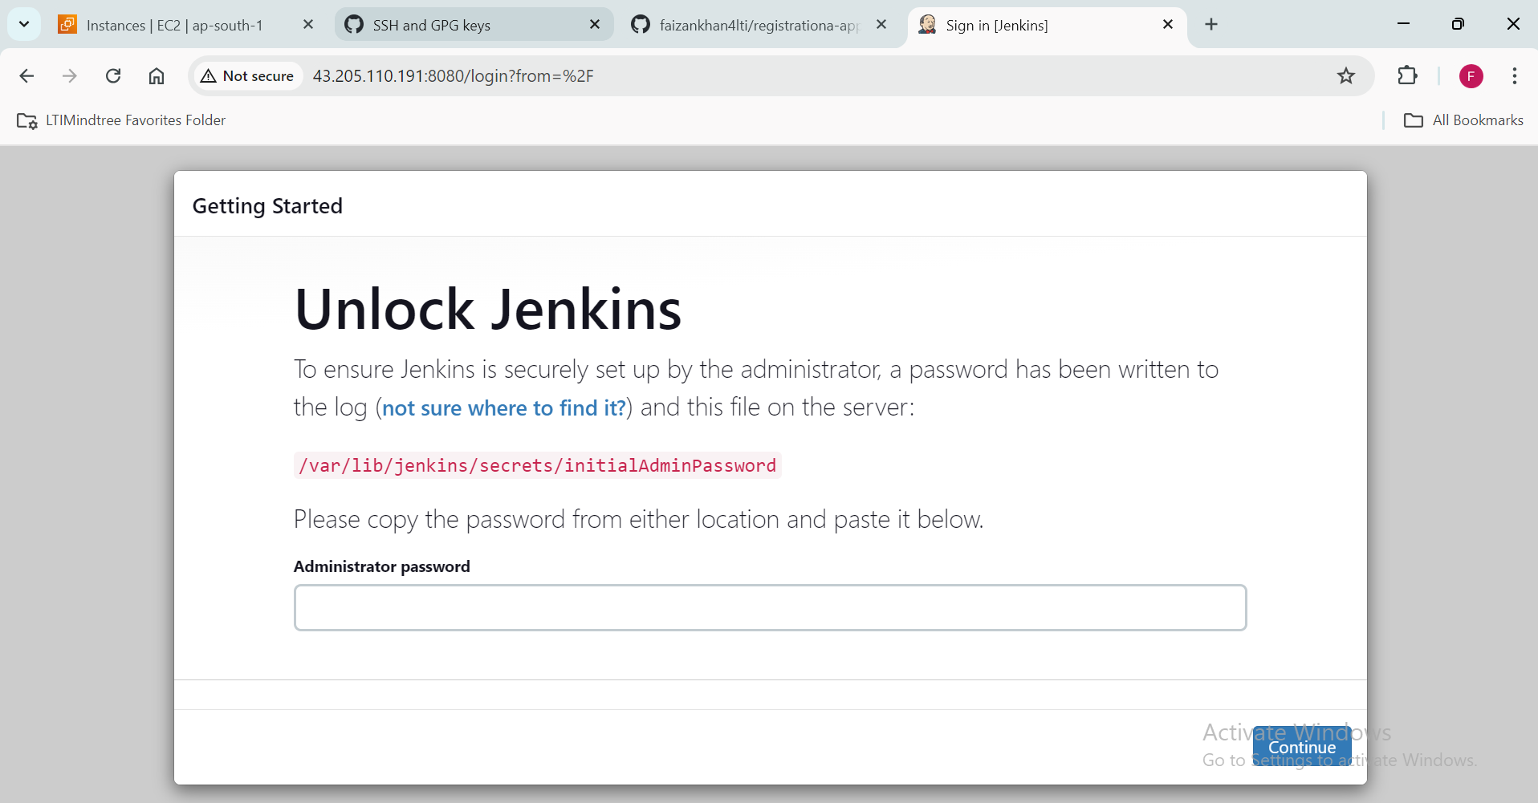



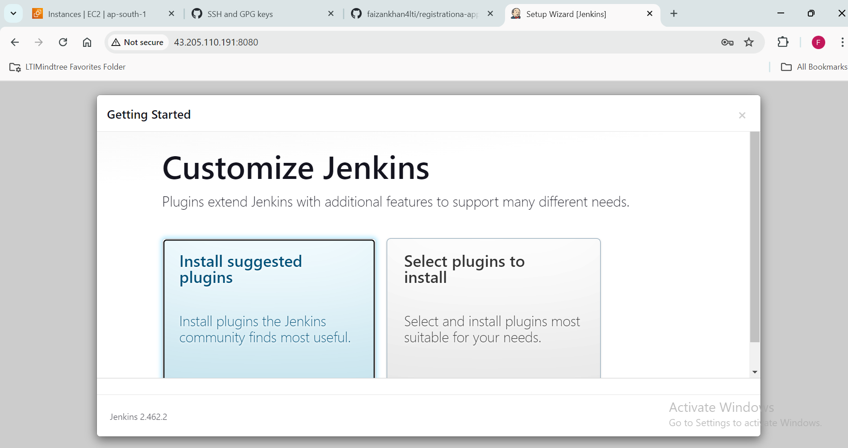

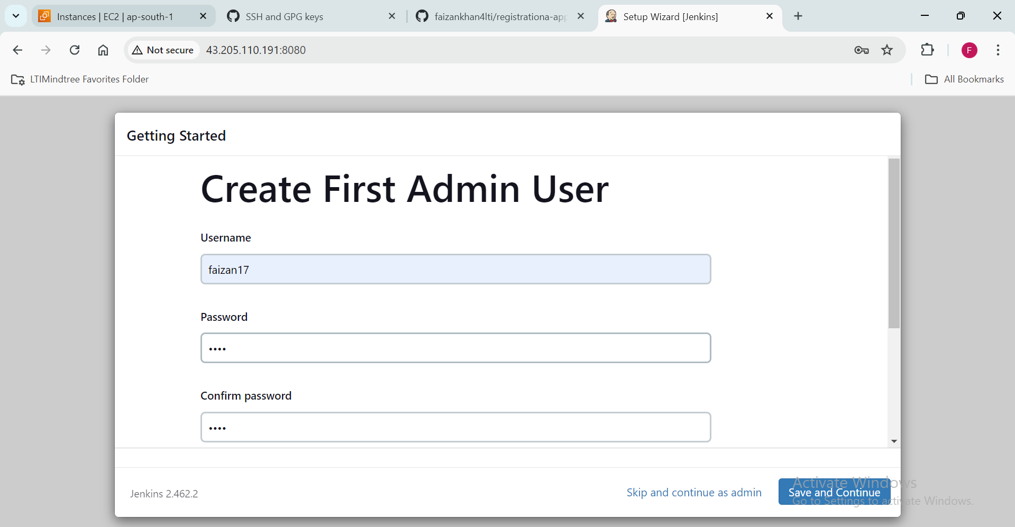

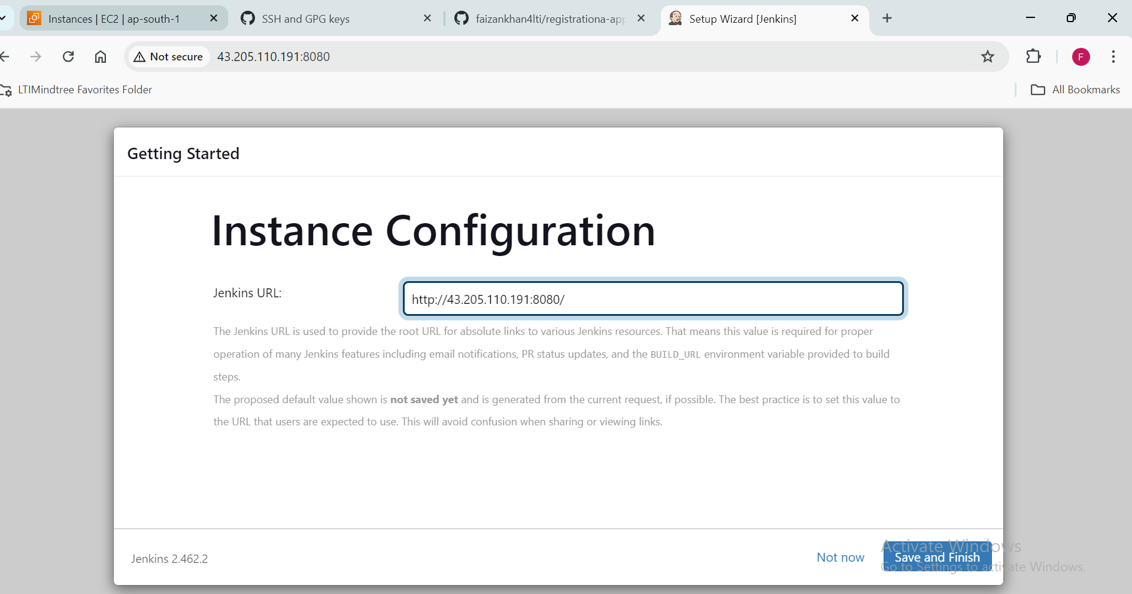

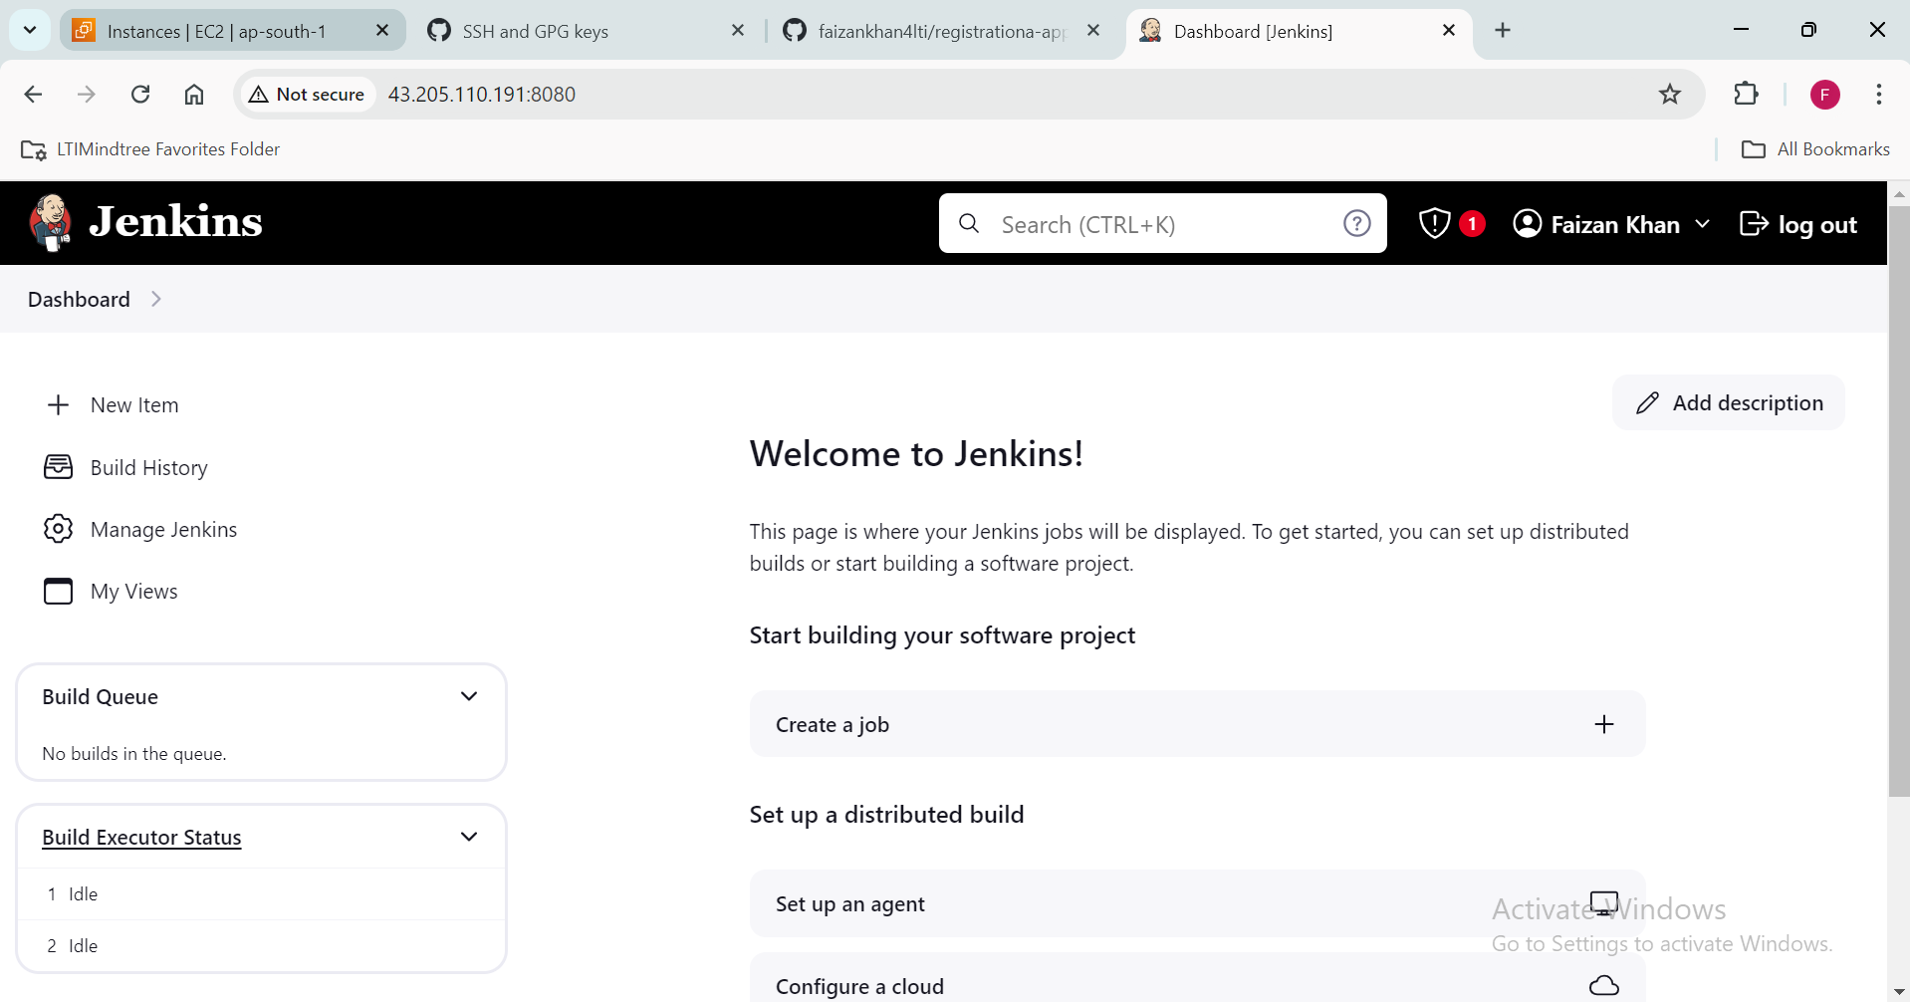

**Installing Maven:**

* Google “download “Maven” and go to the official [Apache Maven site](https://maven.apache.org/download.cgi)
* Right click and copy Link Address on the “tar.gz” file

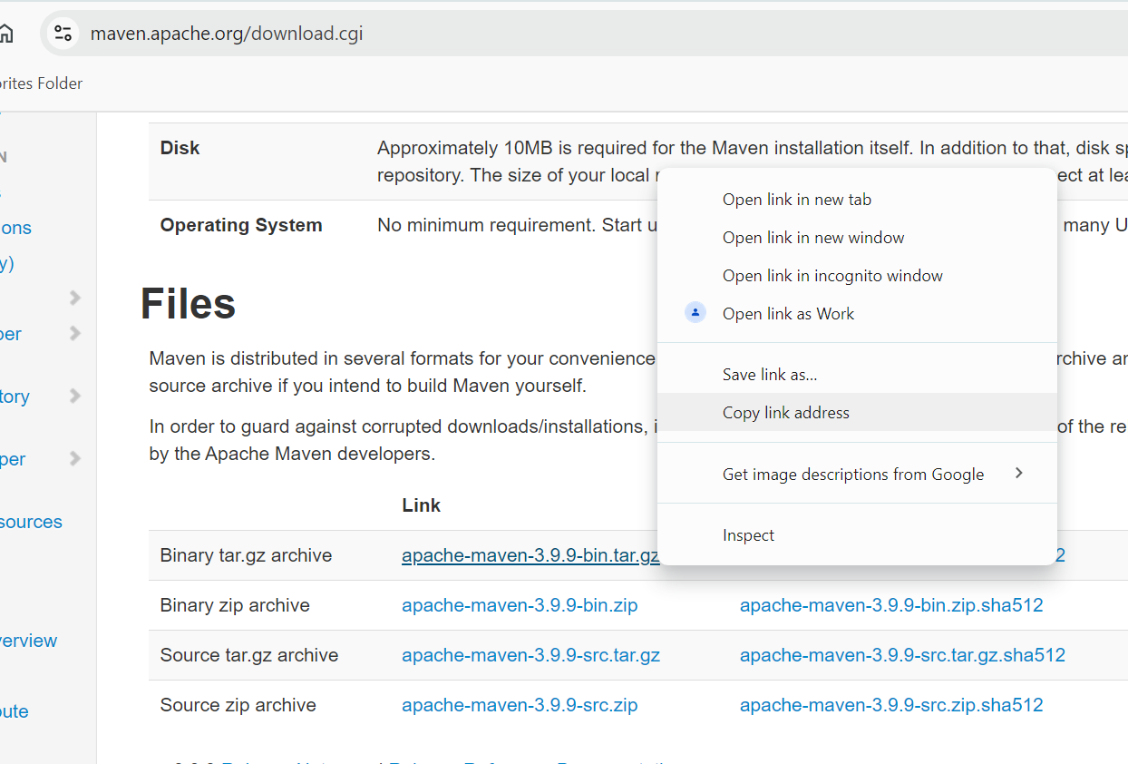

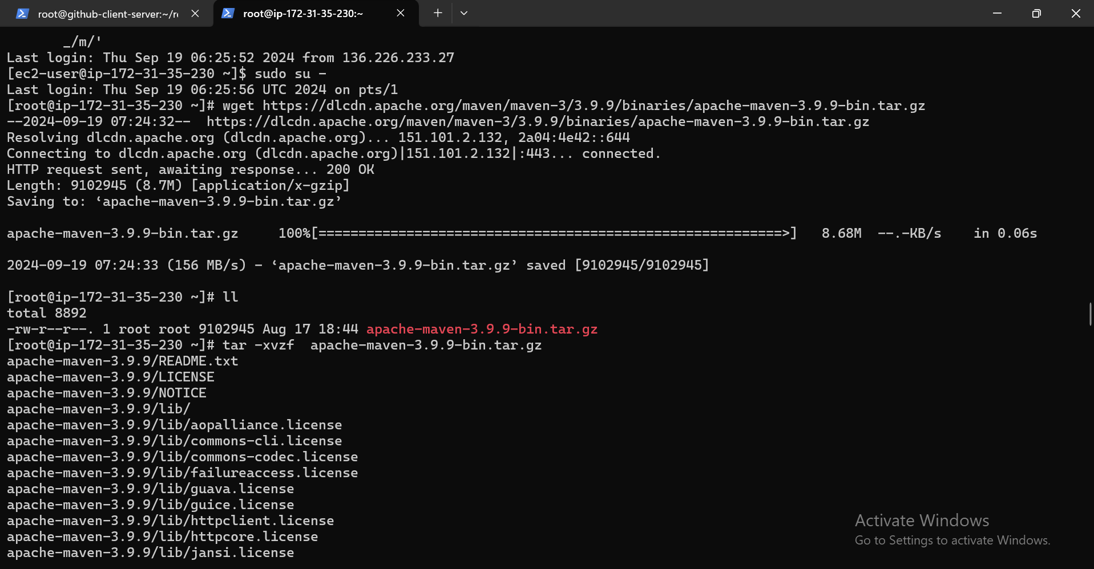

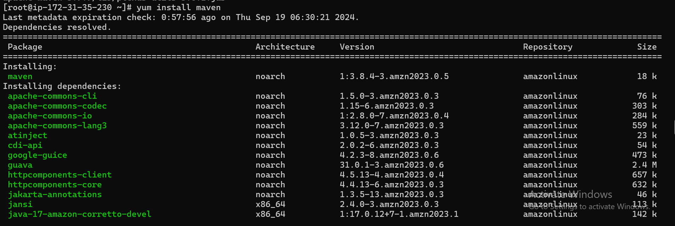

Copy maven path:

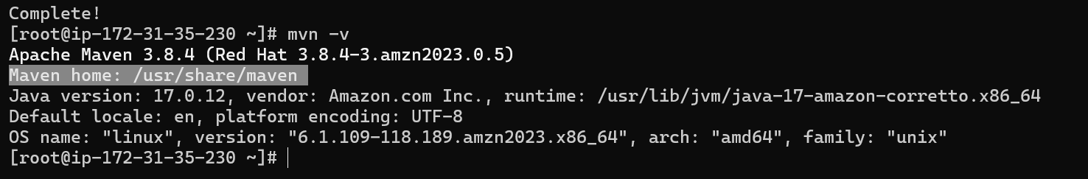

Copy jdk path:

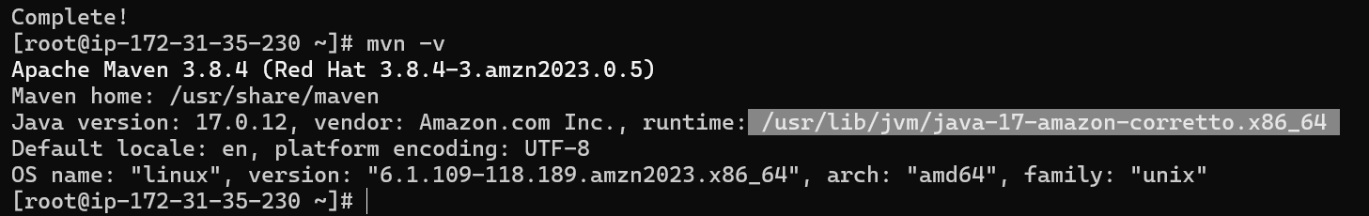

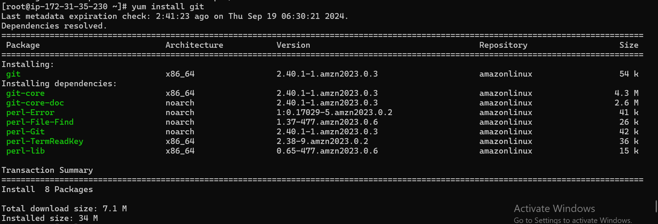

Installing Maven Plugins:

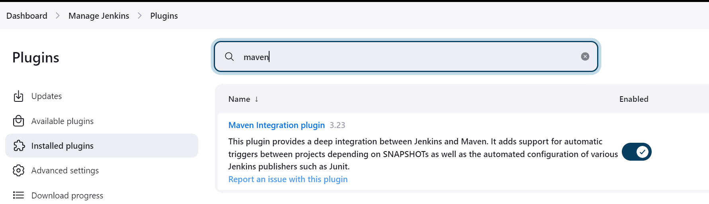

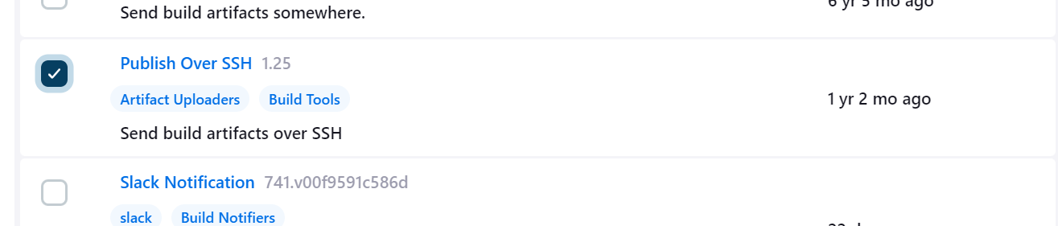

Add jdk path; copied from the terminal

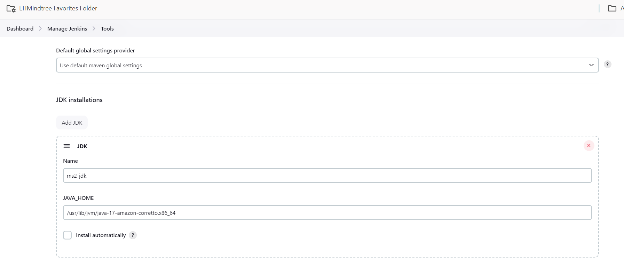

Add Maven Path; copied from the terminal

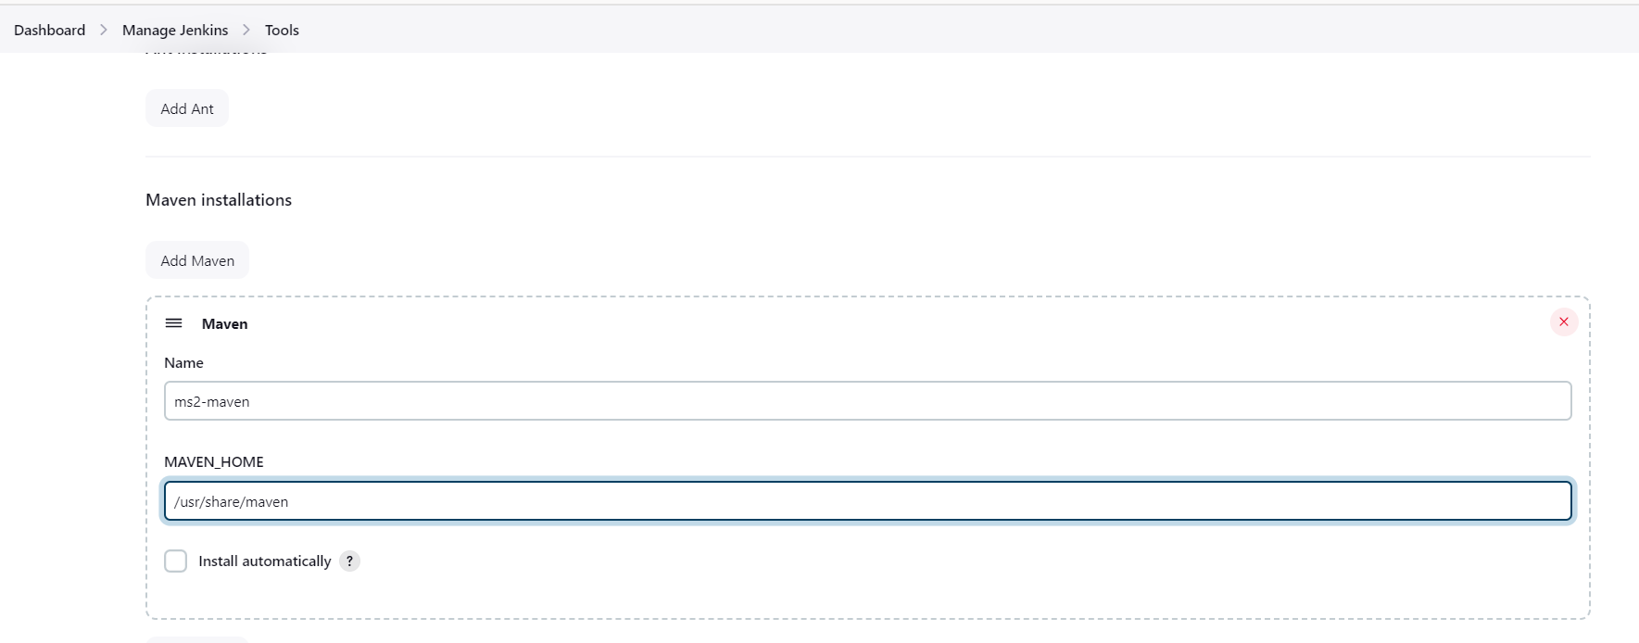

Generate Token

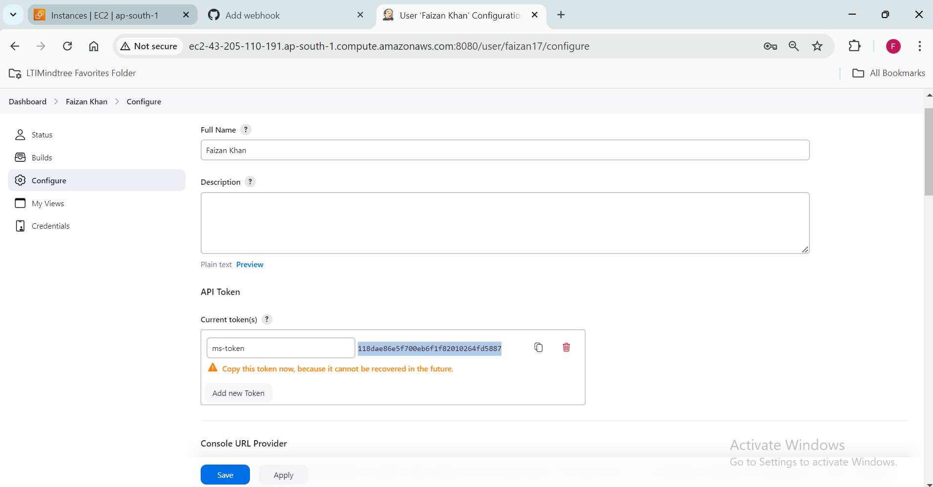

Add Webhook:

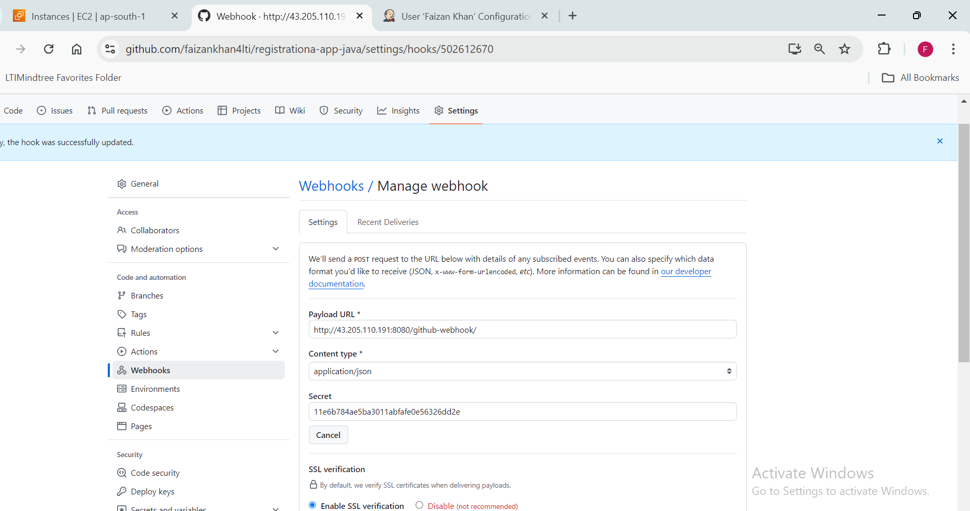

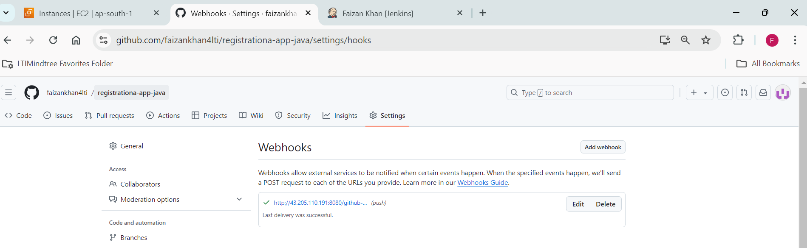

Add Maven plugins:

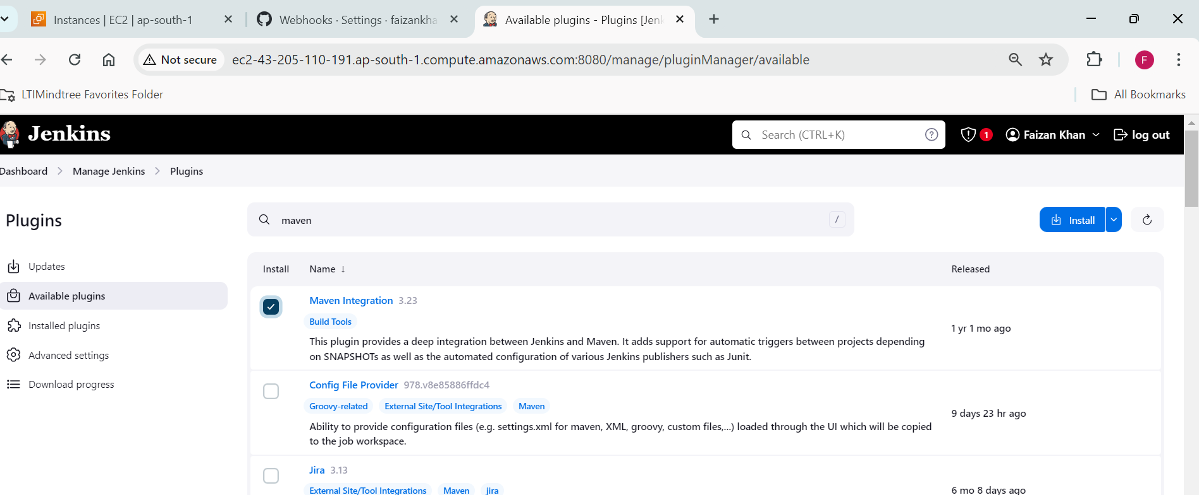

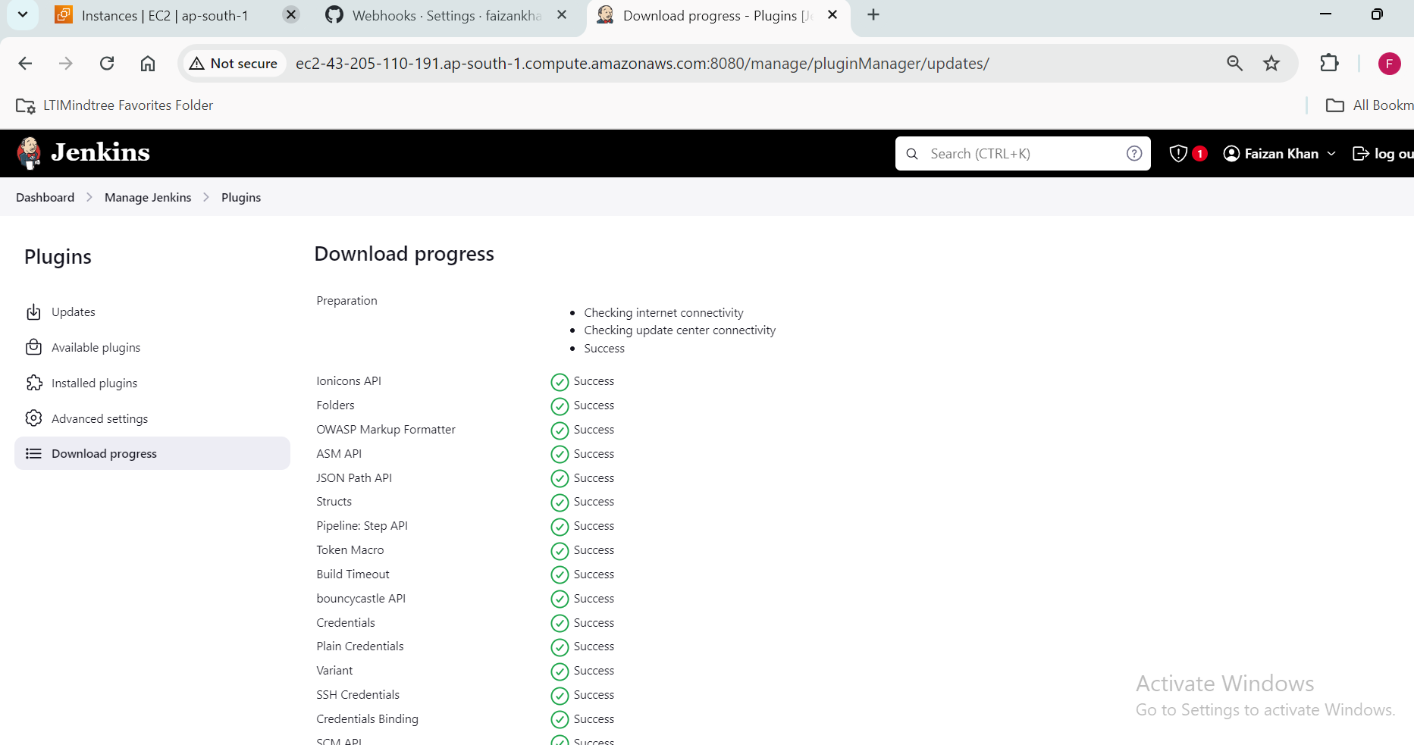

Now we will create a job

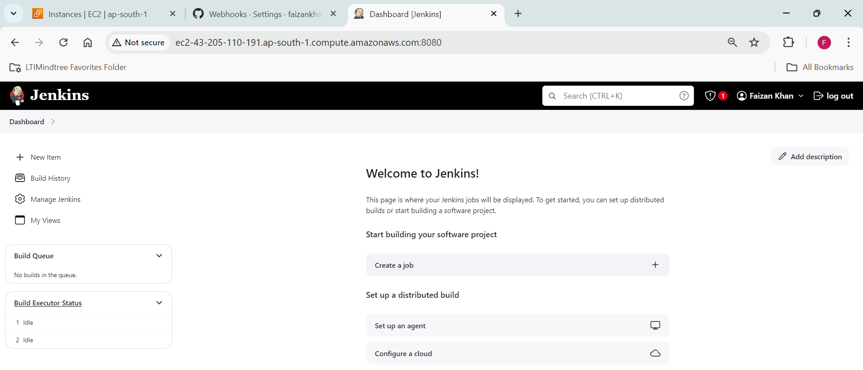

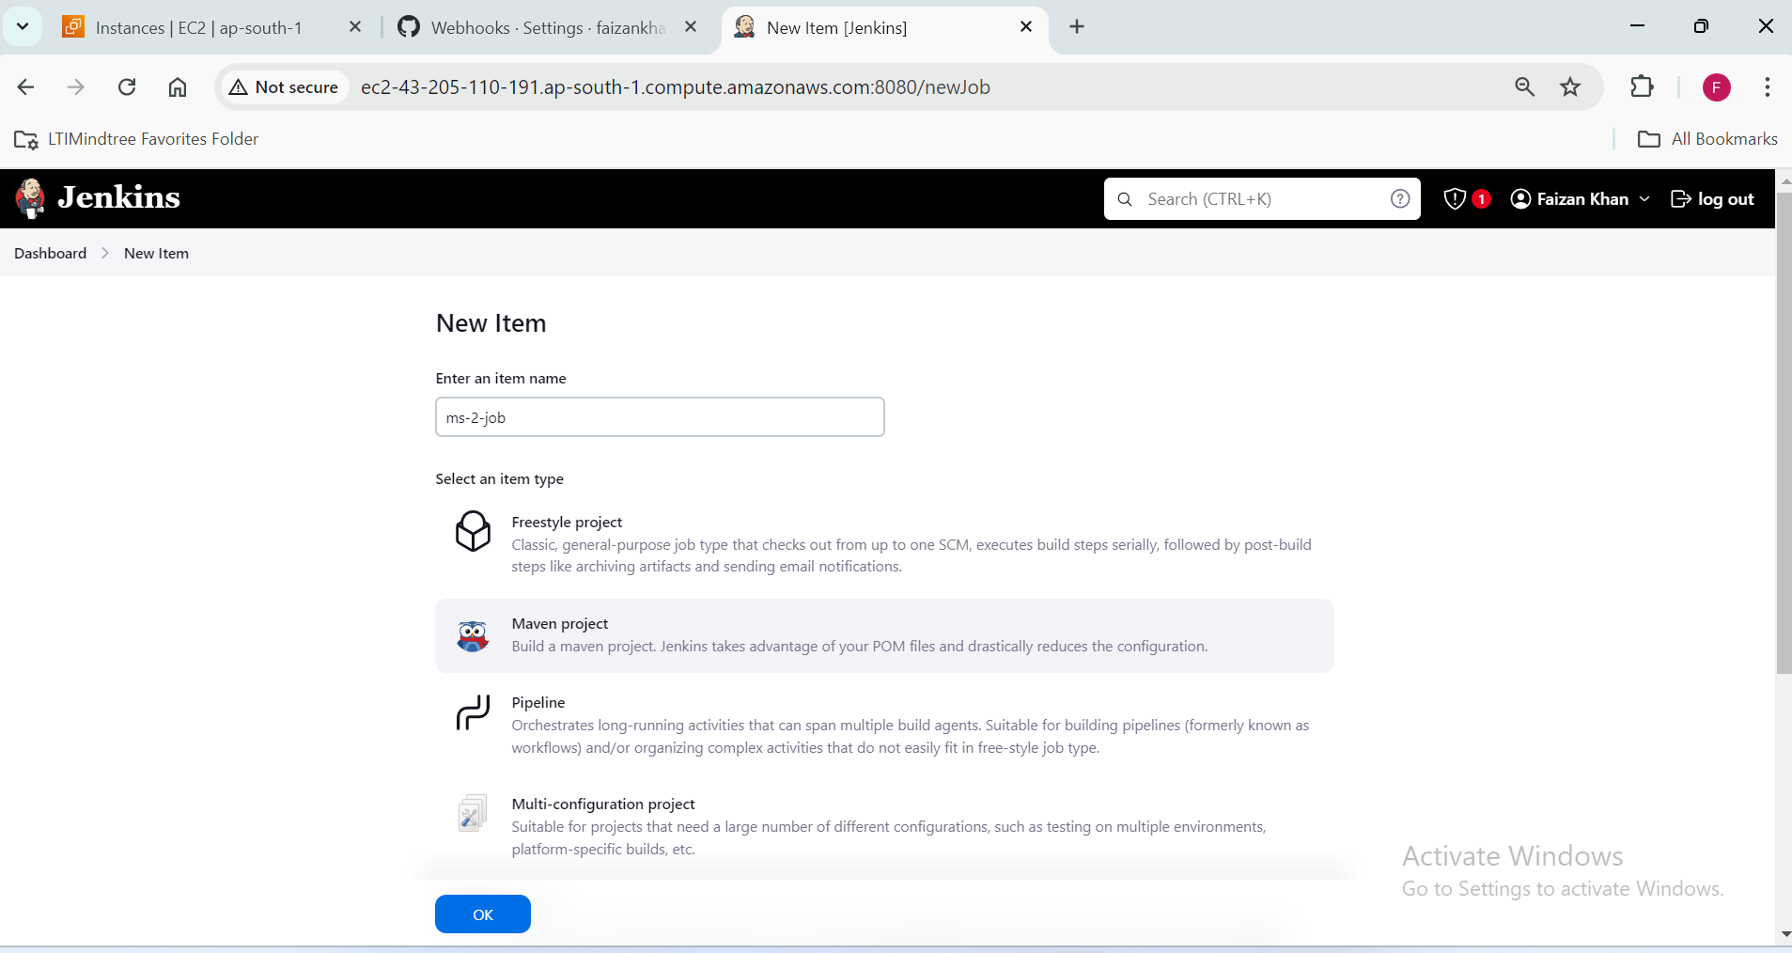

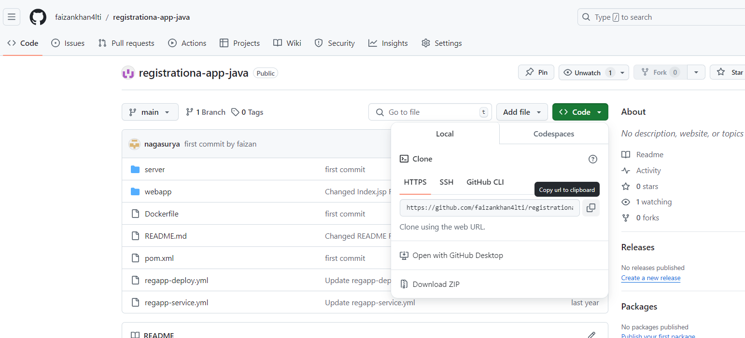

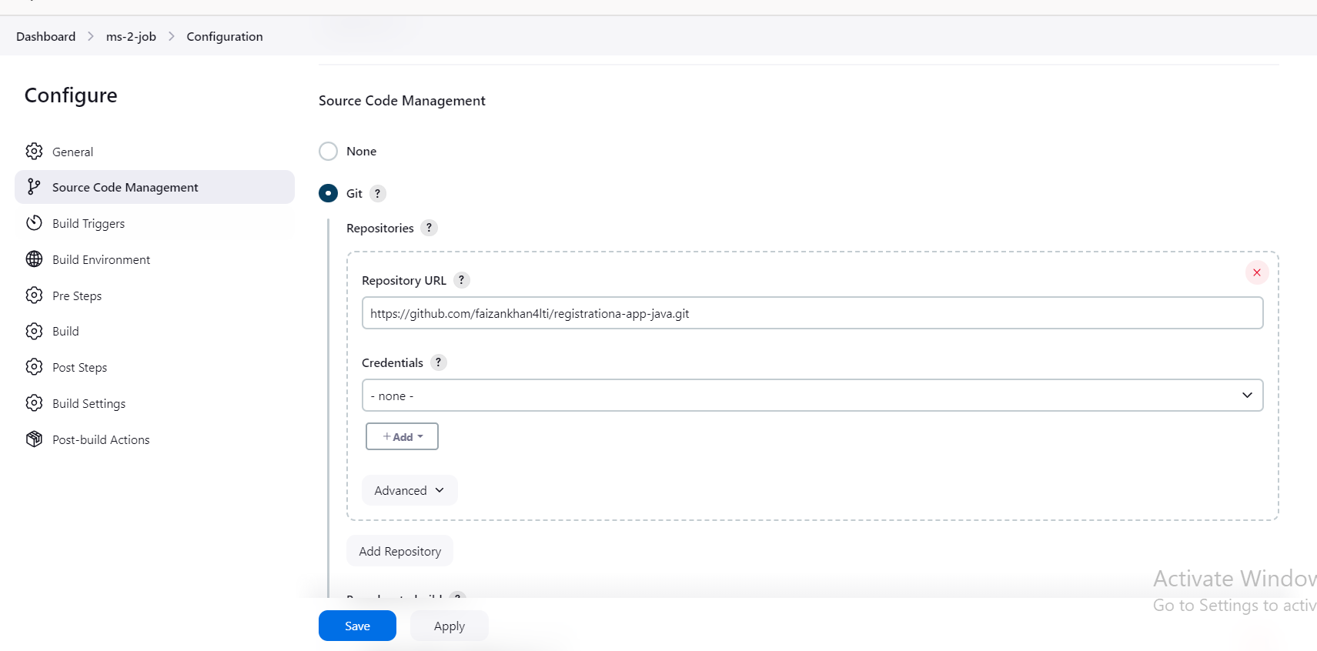

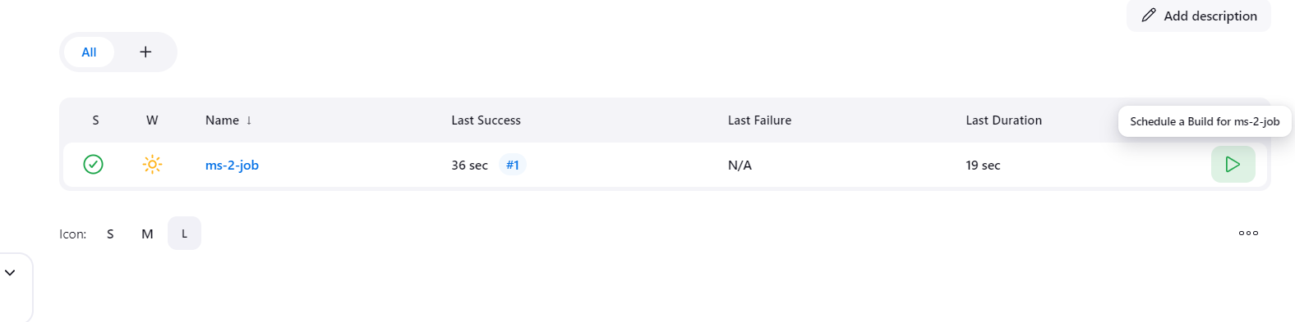

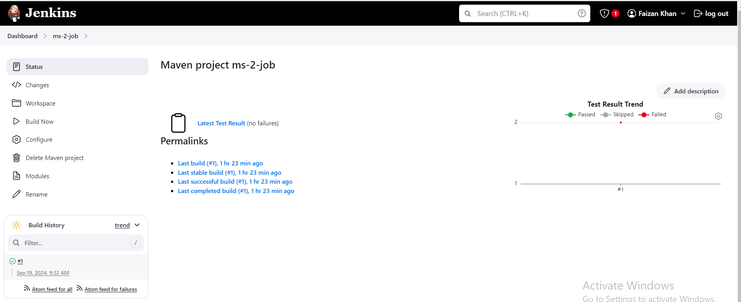

**Installing tomcat:**

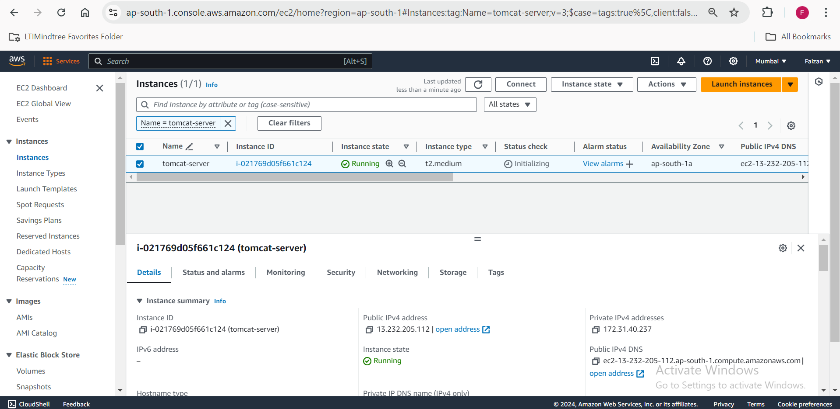

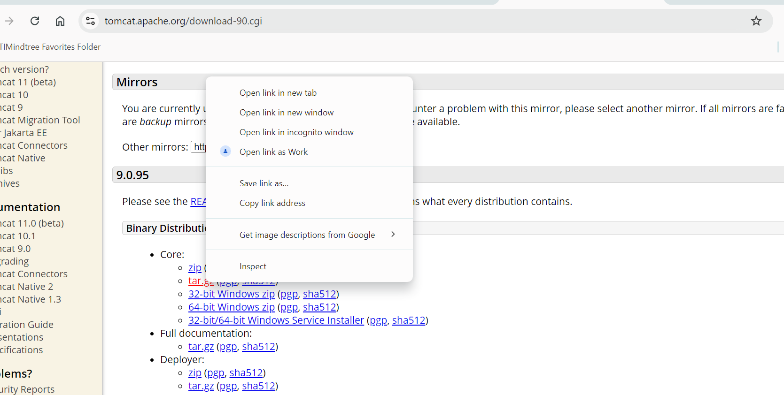

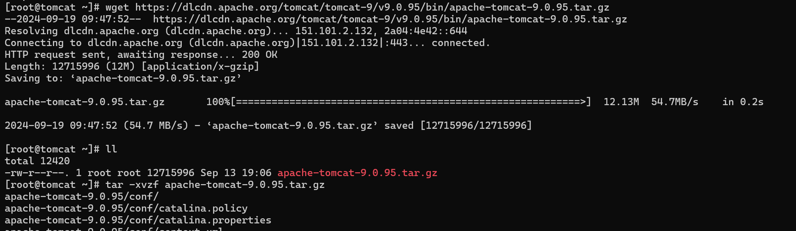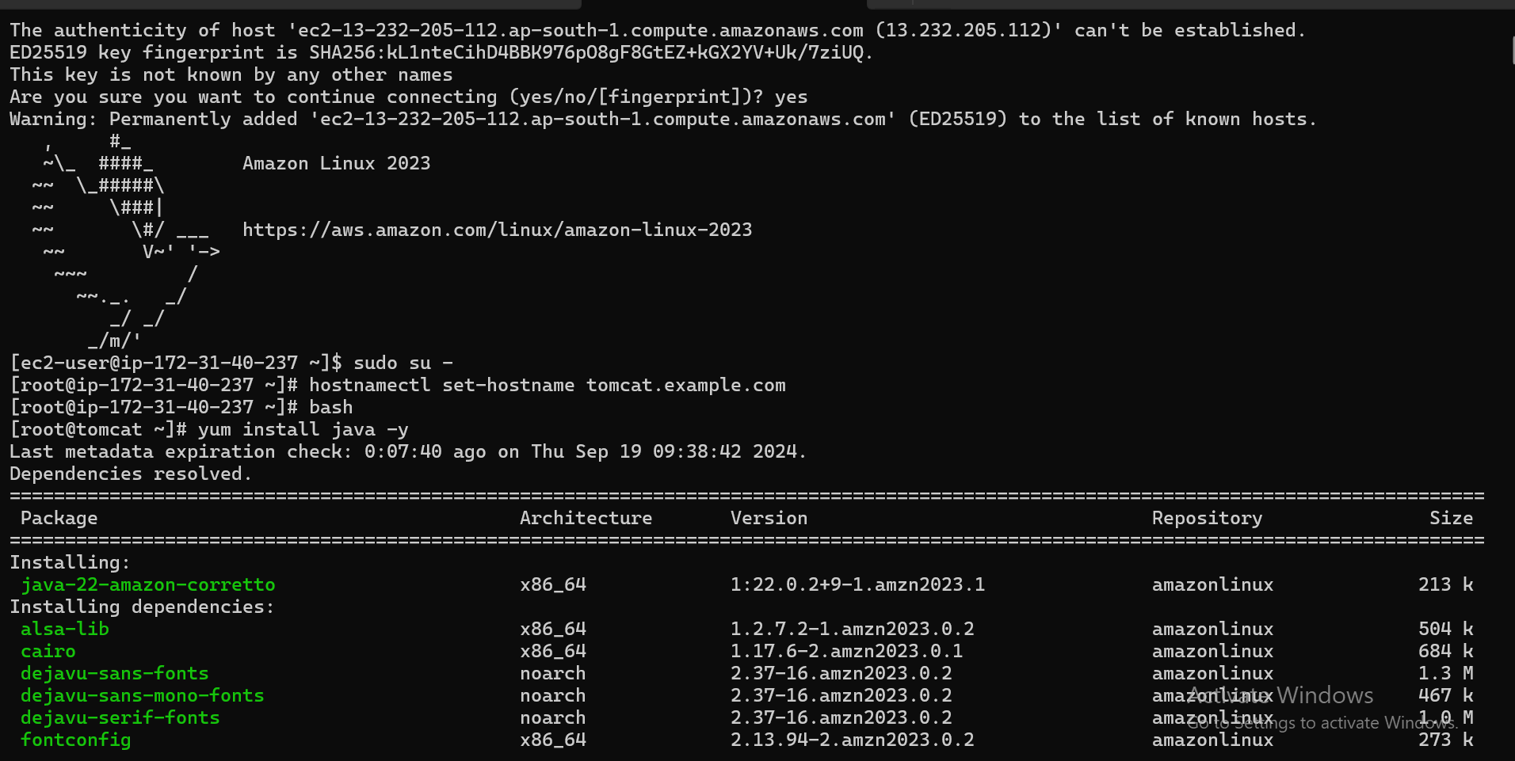

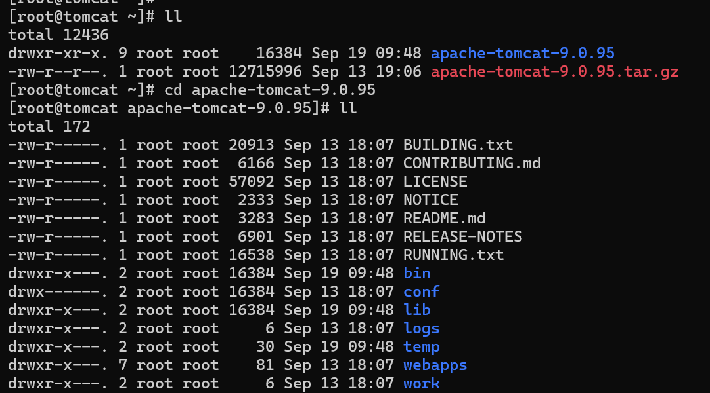

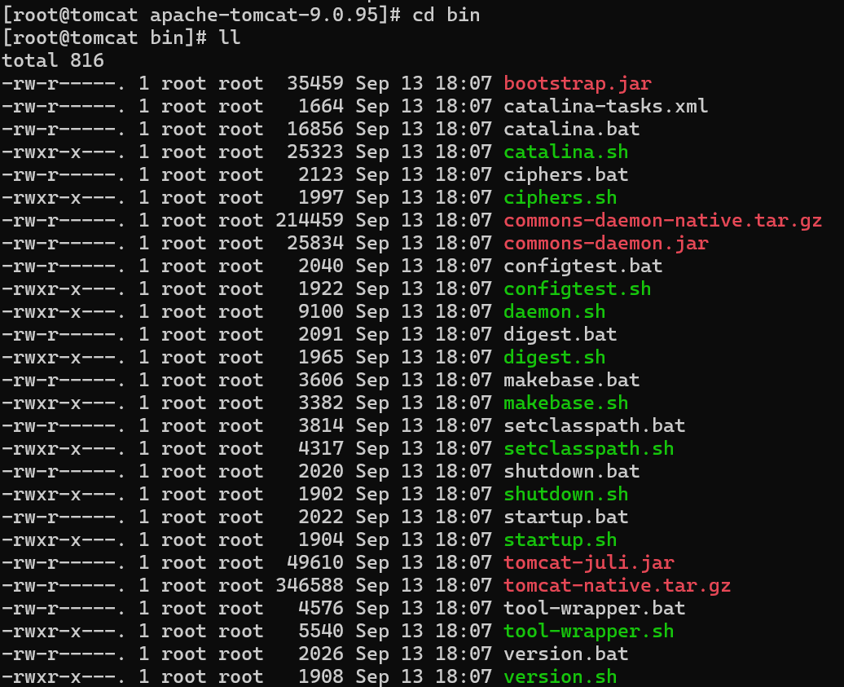

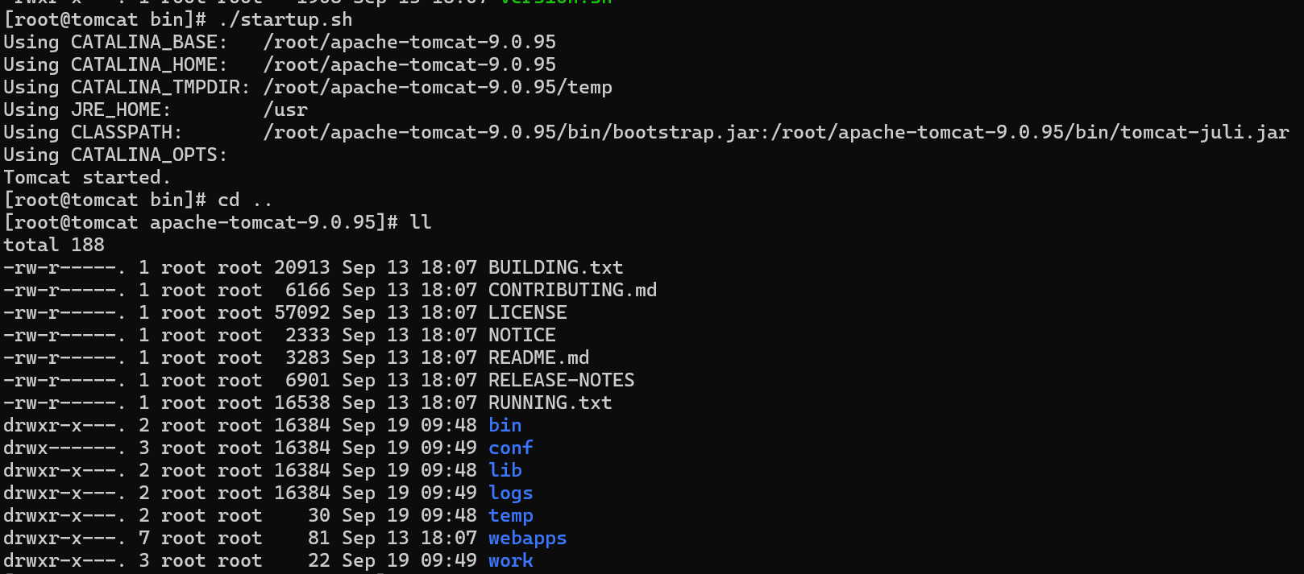

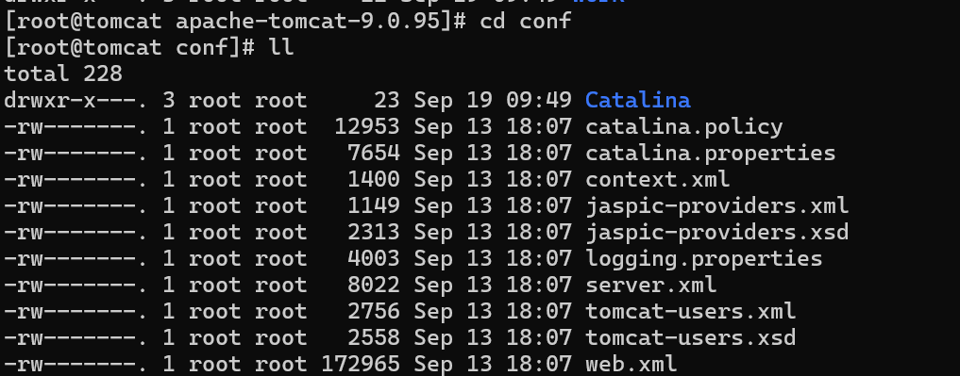

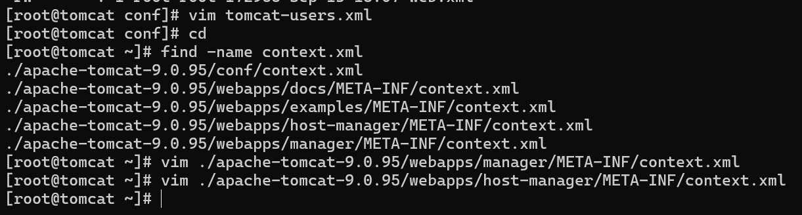

Inside tomcat-user.xml ; paste:

<role rolename="manager-gui"/>

<role rolename="manager-script"/>

<role rolename="manager-jmx"/>

<role rolename="manager-status"/>

<user username="admin" password="admin" roles="manager-gui, manager-script, manager-jmx, manager-status"/>

<user username="deployer" password="deployer" roles="manager-script"/>

<user username="tomcat" password="s3cret" roles="manager-gui"/>

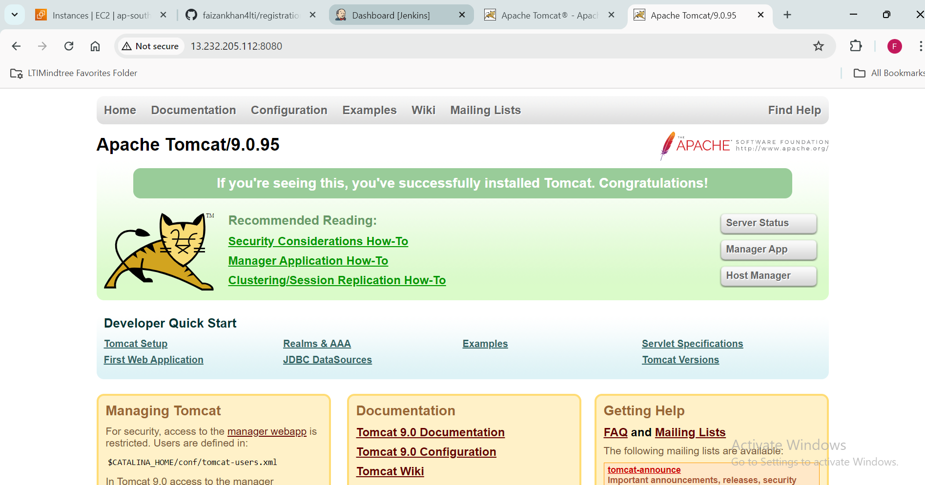

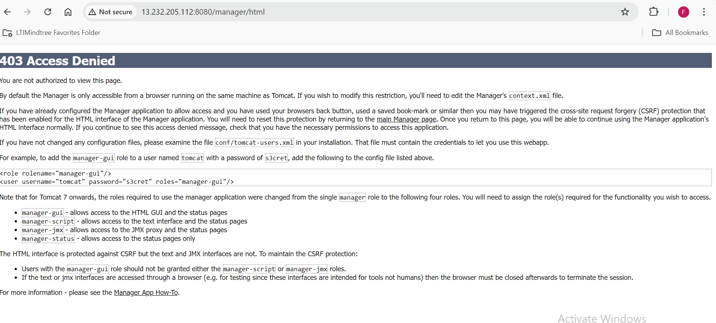

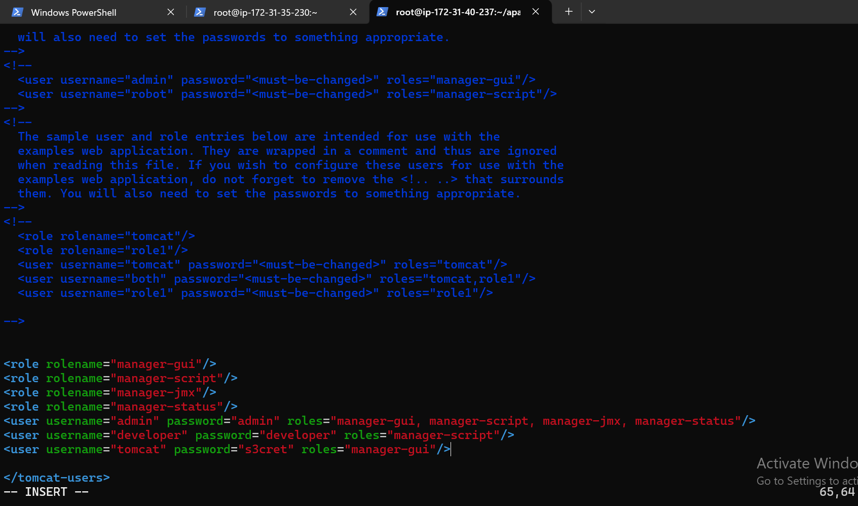

**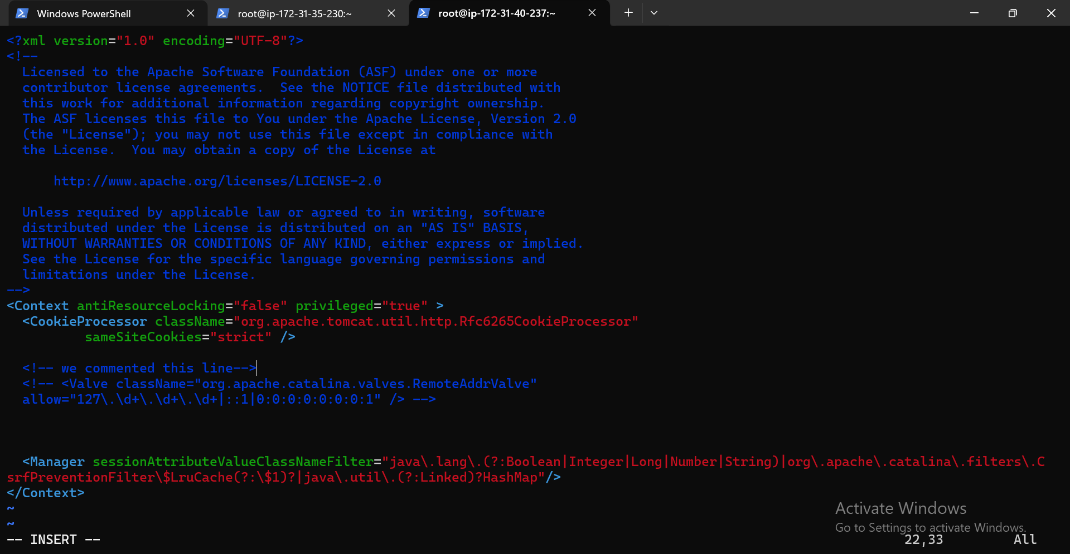  
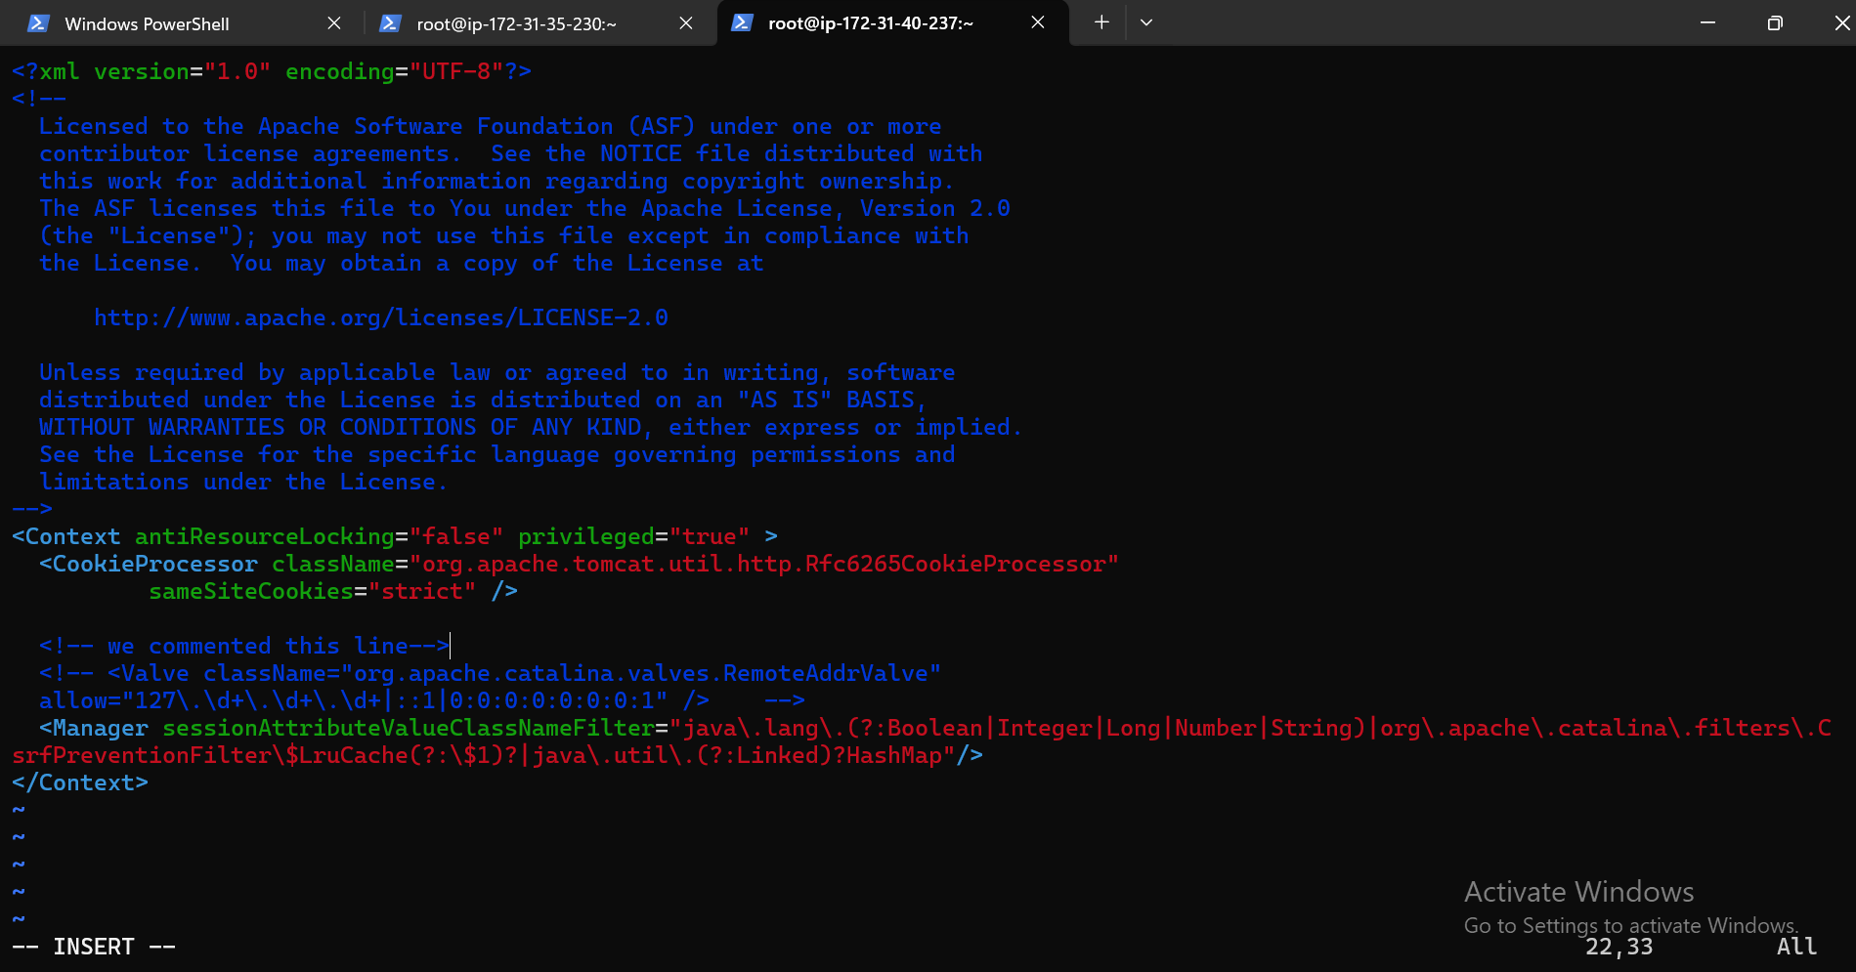**

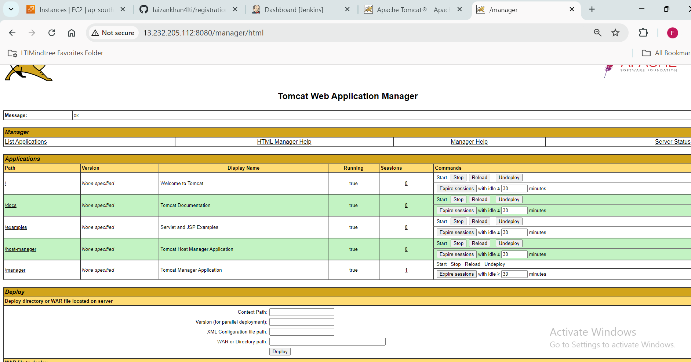

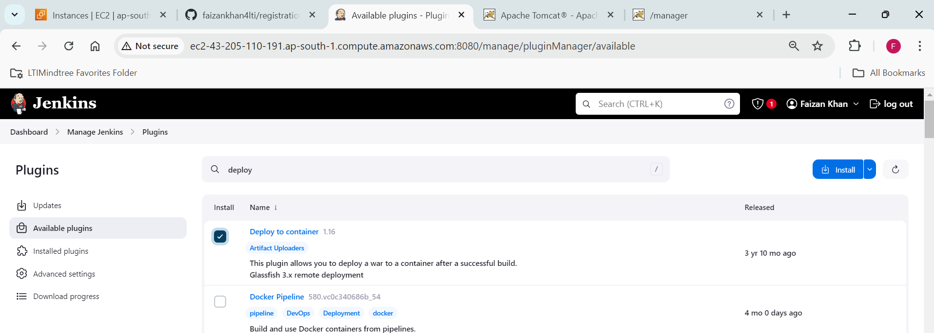

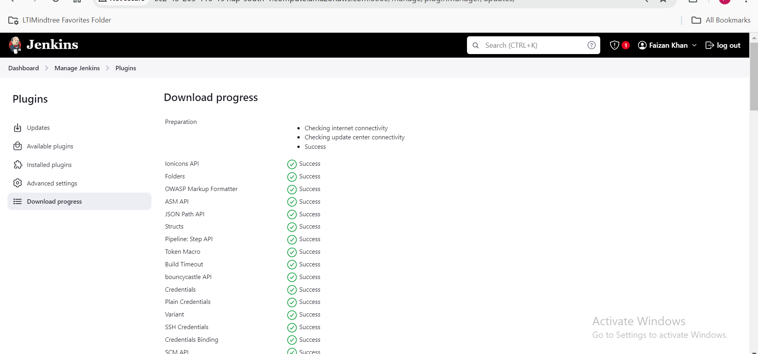

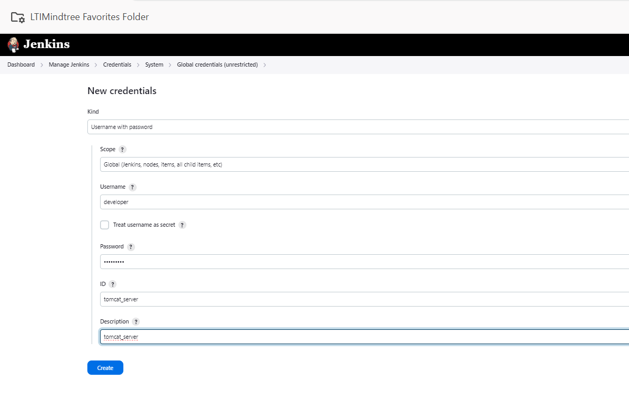

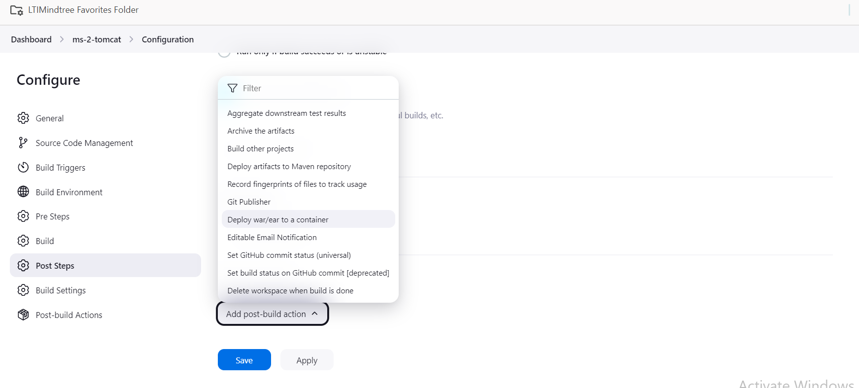

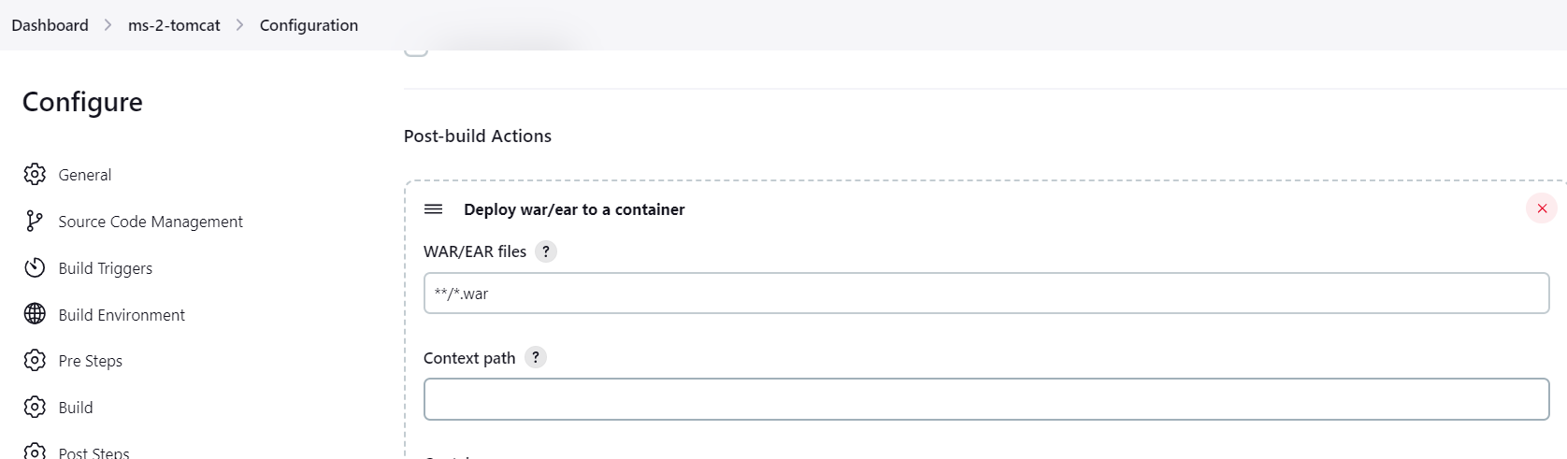

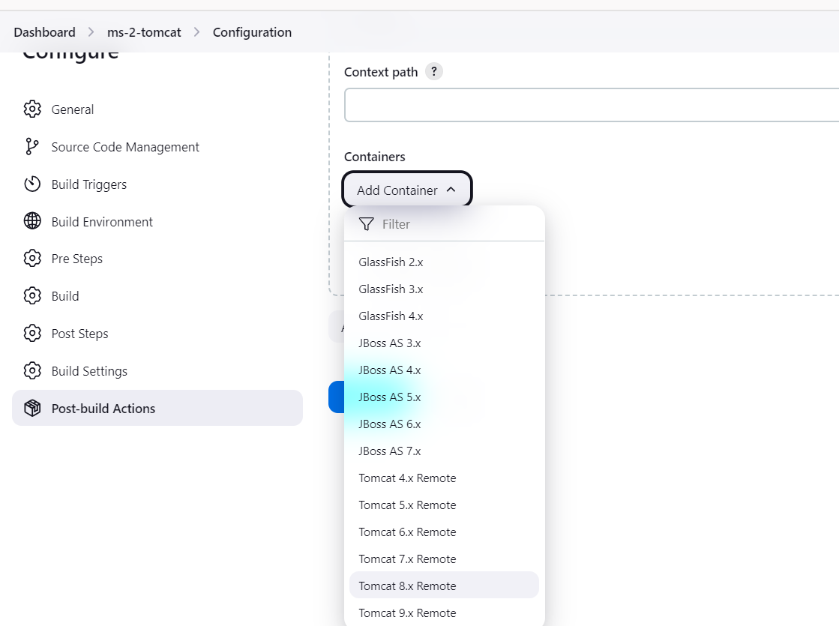

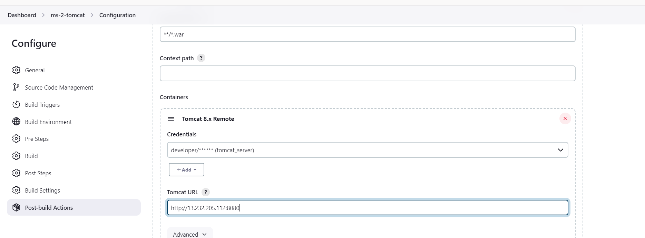

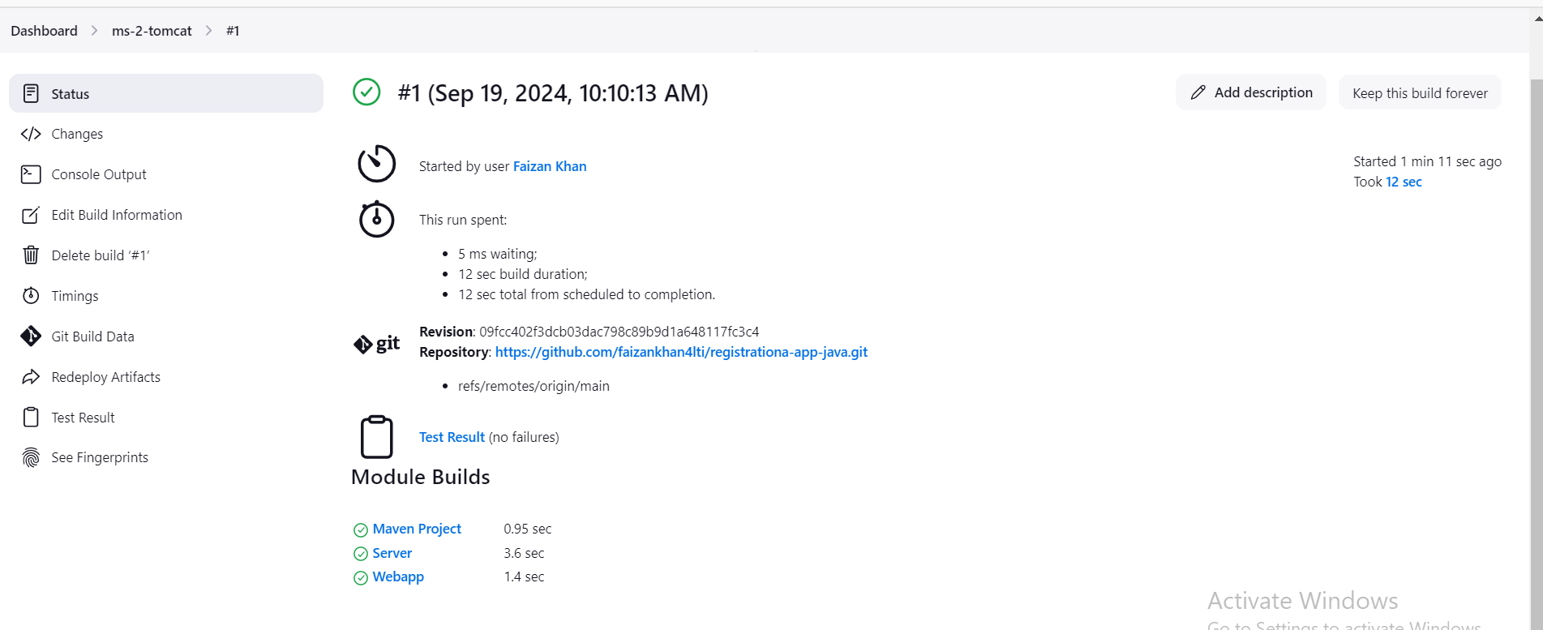

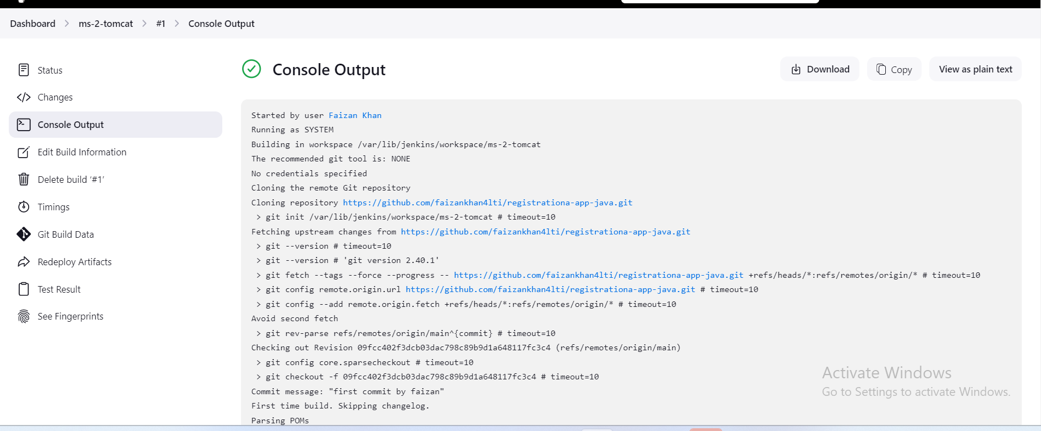

Docker:

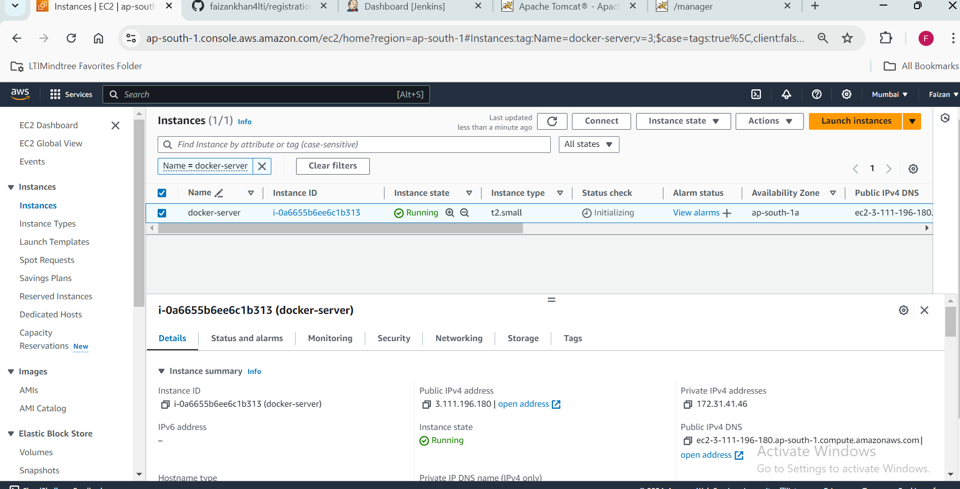

Ssh-keygen

Copy the public key of both the server(tomcat server and docker server) inside Jenkins server.





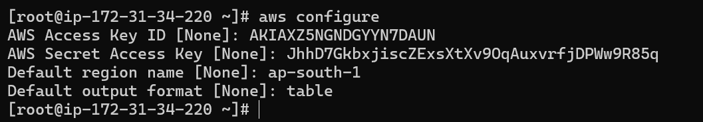

(Allow ‘root login’ and ‘password authinticator’, ‘ permit empty password’ in both Jenkins server in docker server)



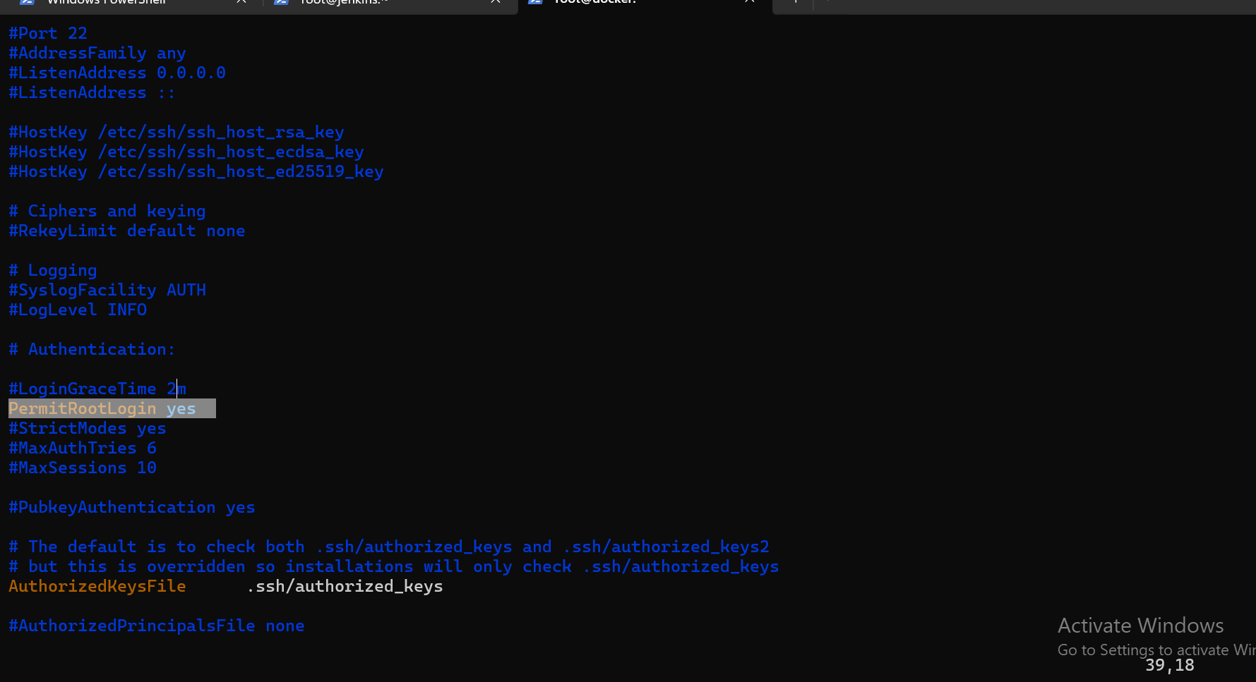

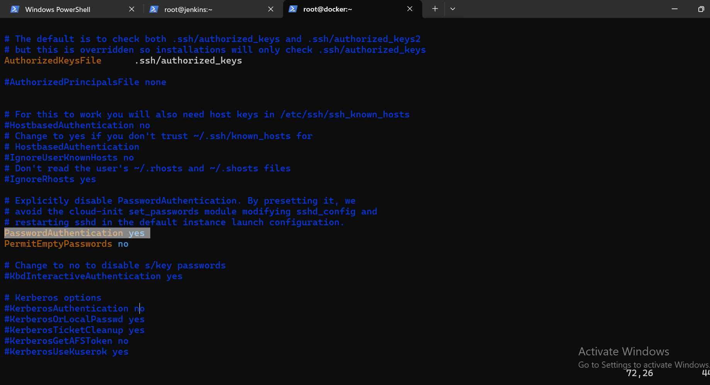

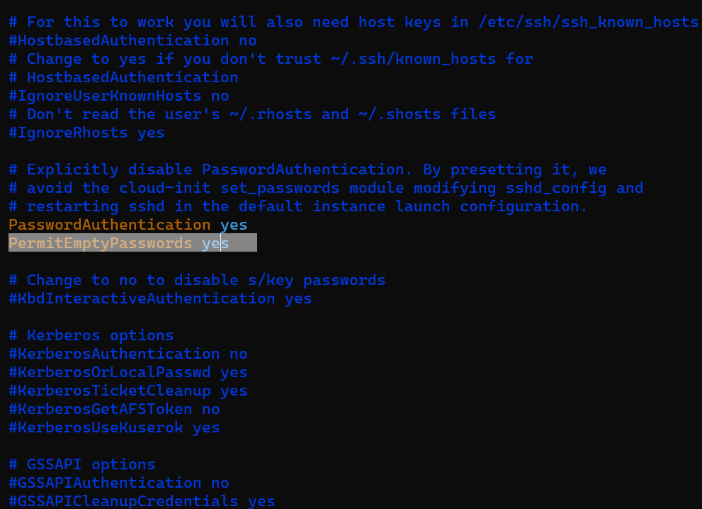

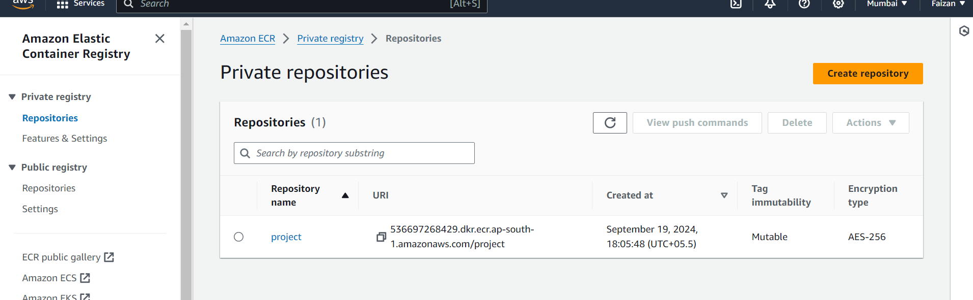

Copy Jenkins public key

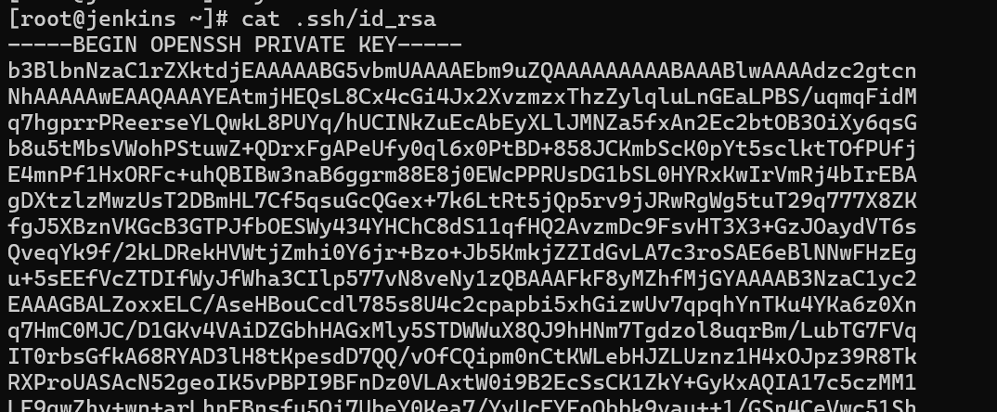

Past it here

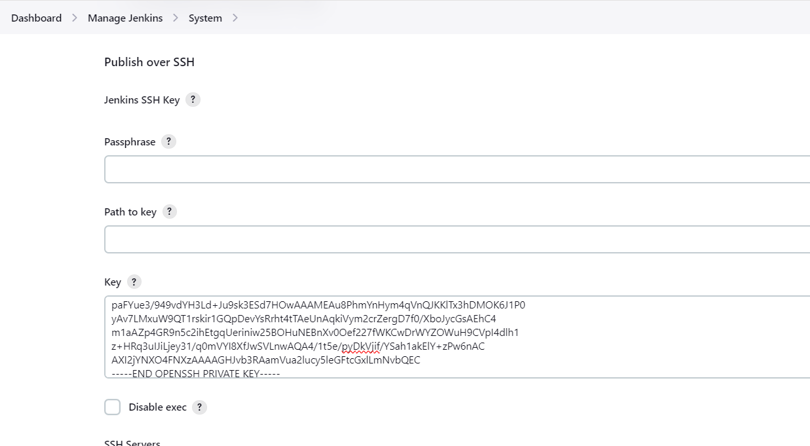

Copy ip of Jenkins server

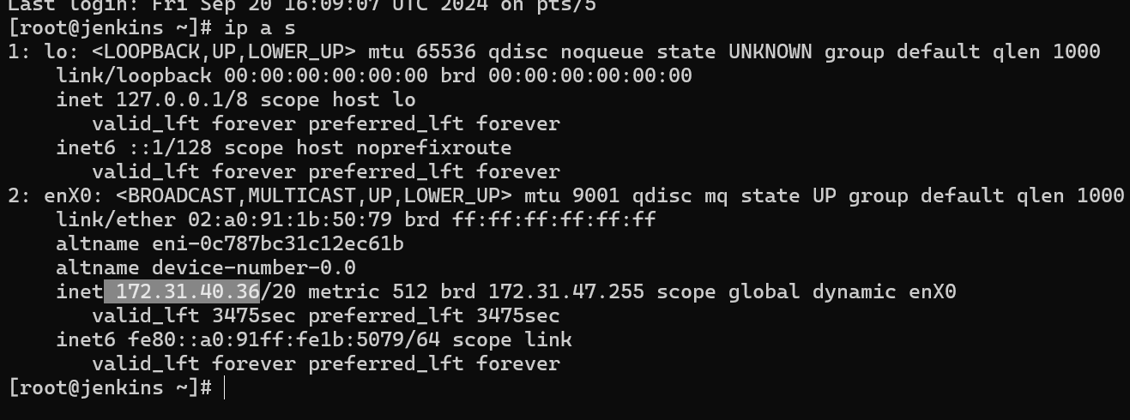

Pate it here

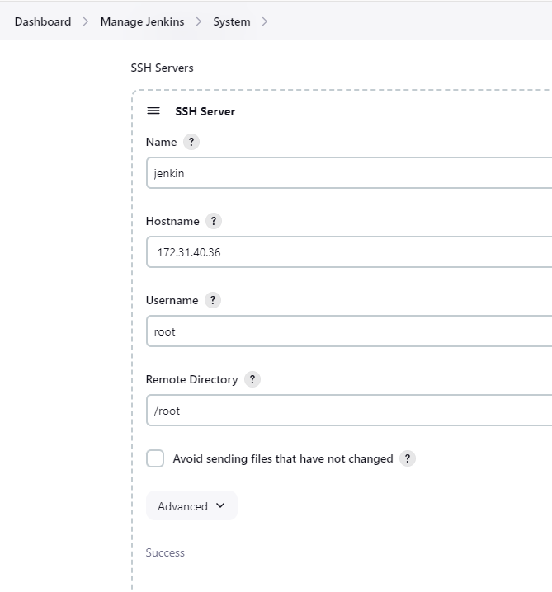

Similarly paste ip address of docker server here

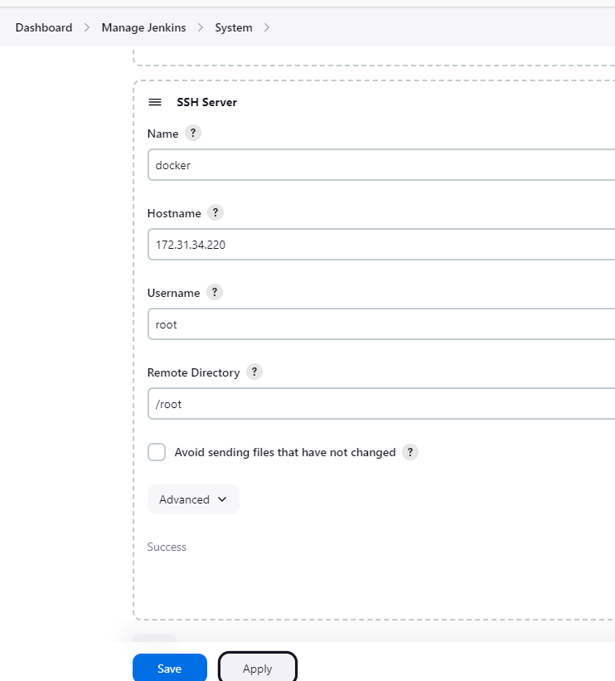

Apply and save

Command:

rsync -avh /var/lib/jenkins/workspace/[job-name]/* root@[ip-address of docker]:/opt

here; rsync -avh /var/lib/jenkins/workspace/m2-tomcat/* root@172.31.34.220:/opt



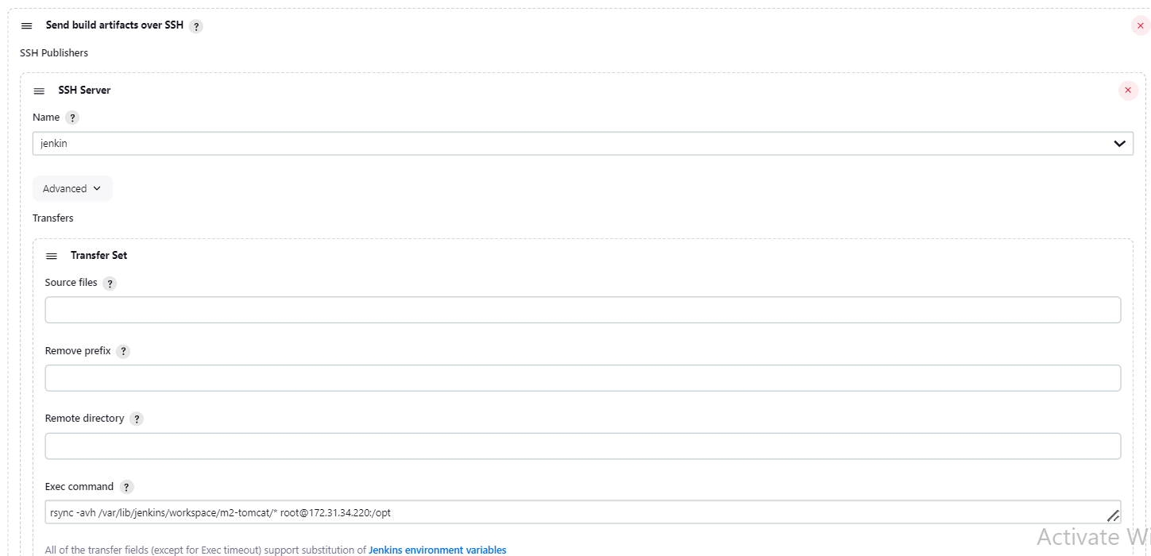

Go to Amazon ECR -> View Push Command

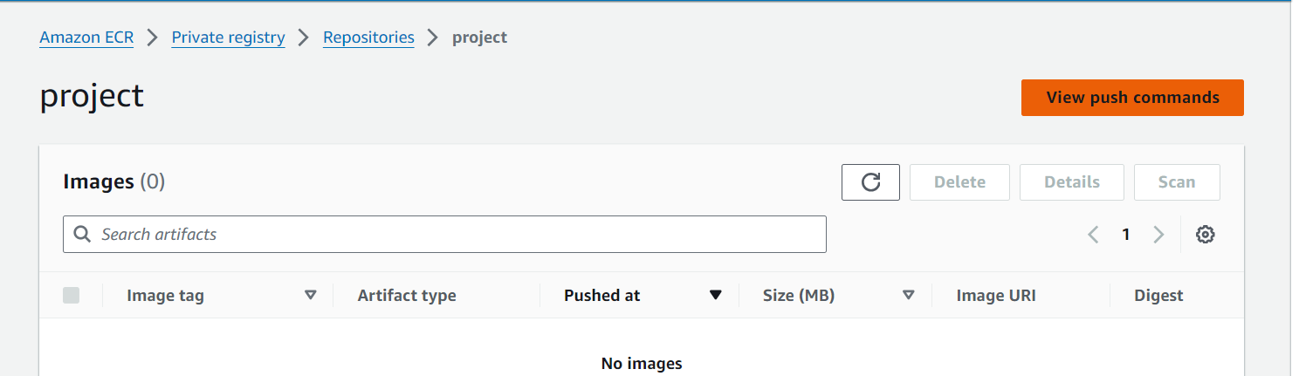

Copy this command

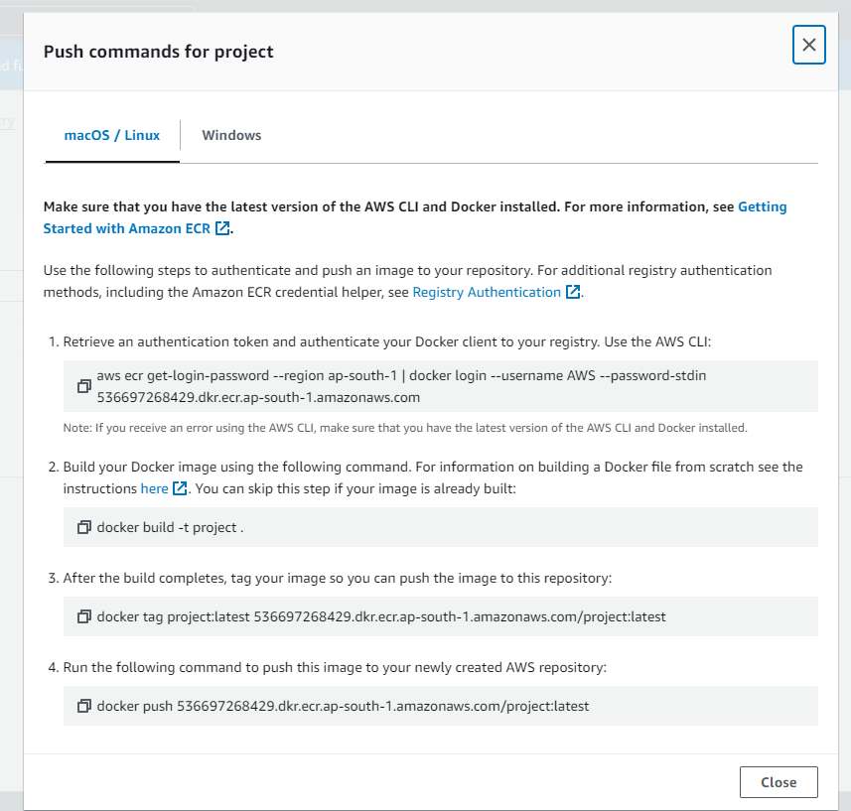

Paste it here

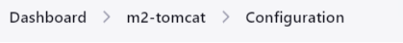



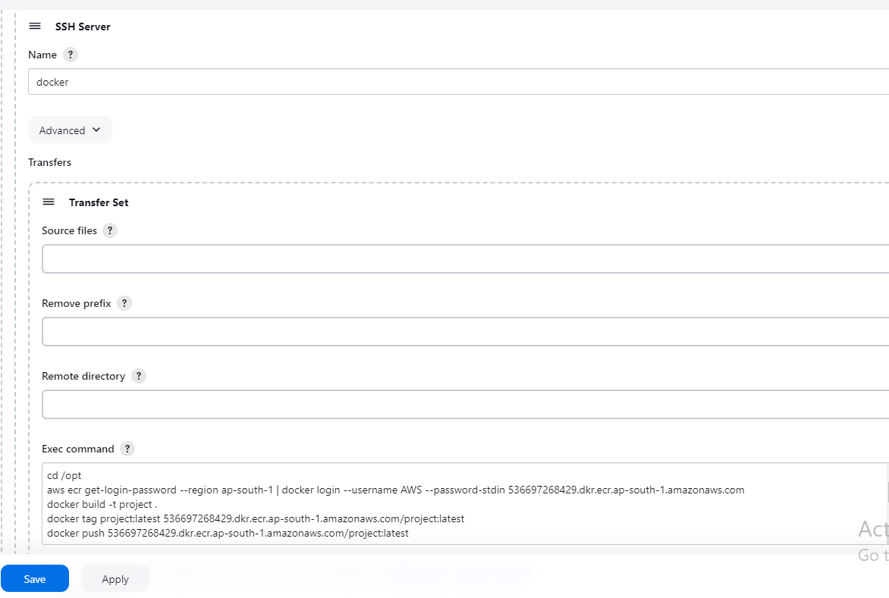

If any error comes; run these commands line by line to check and restart the docker in case

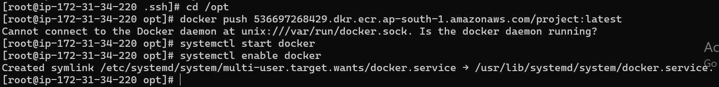

Built:

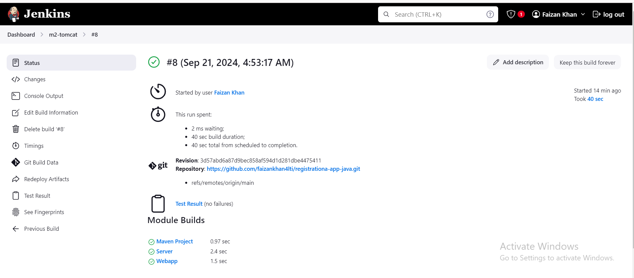

**Eks:** [**link**](https://github.com/Prasad-LTIMindtree/devops-sheet/blob/main/ekscluster)

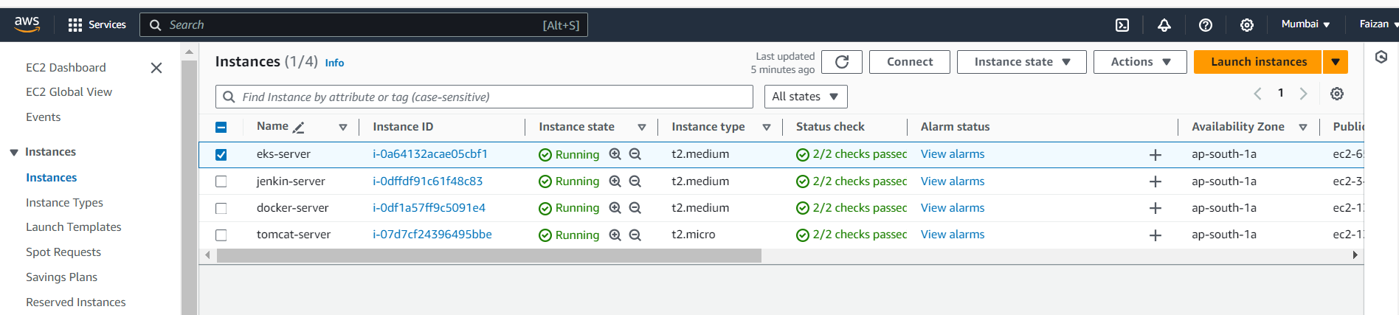

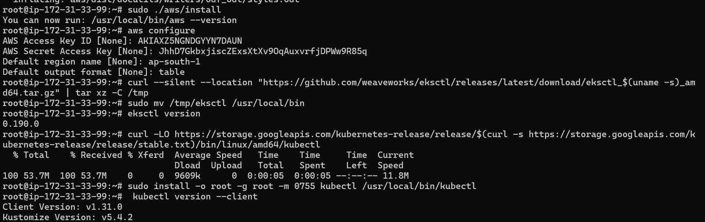

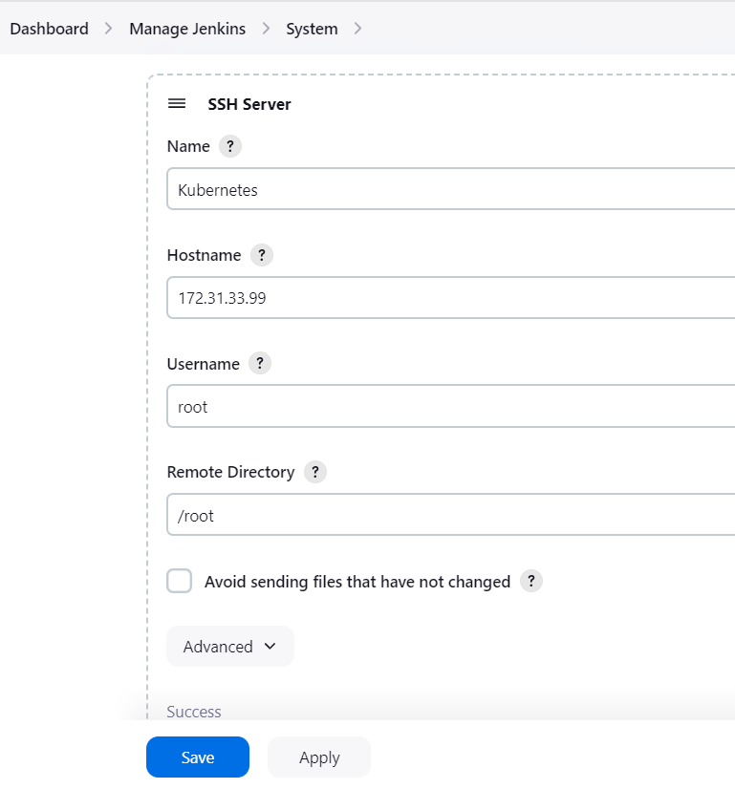

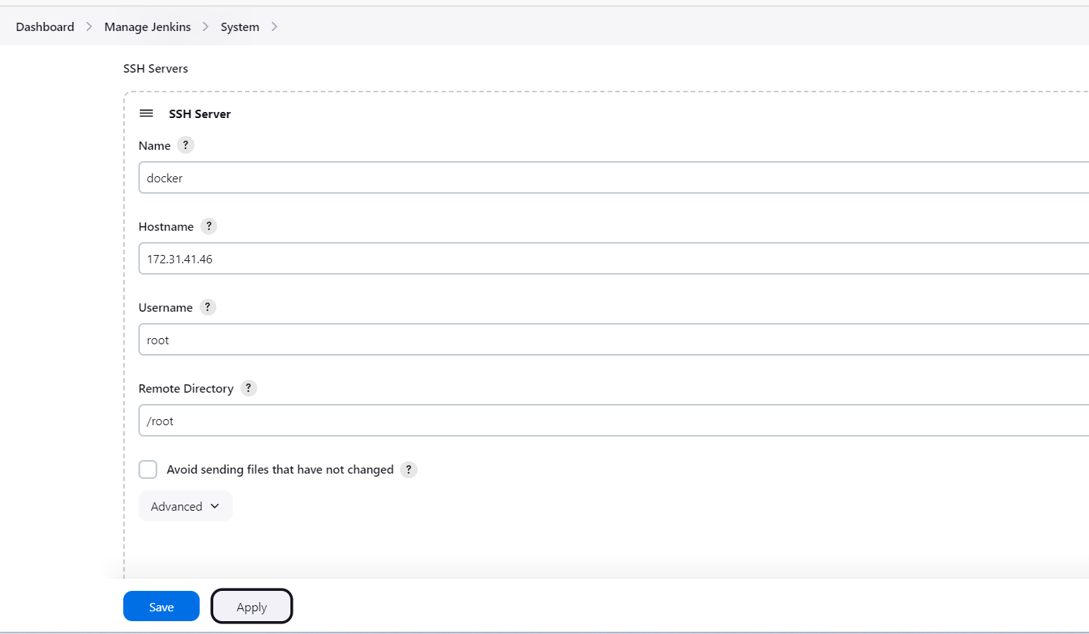

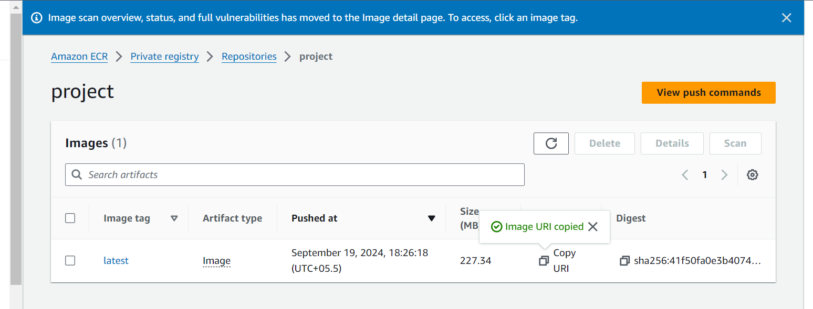

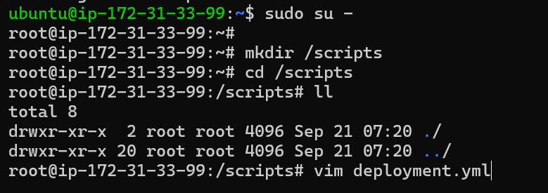

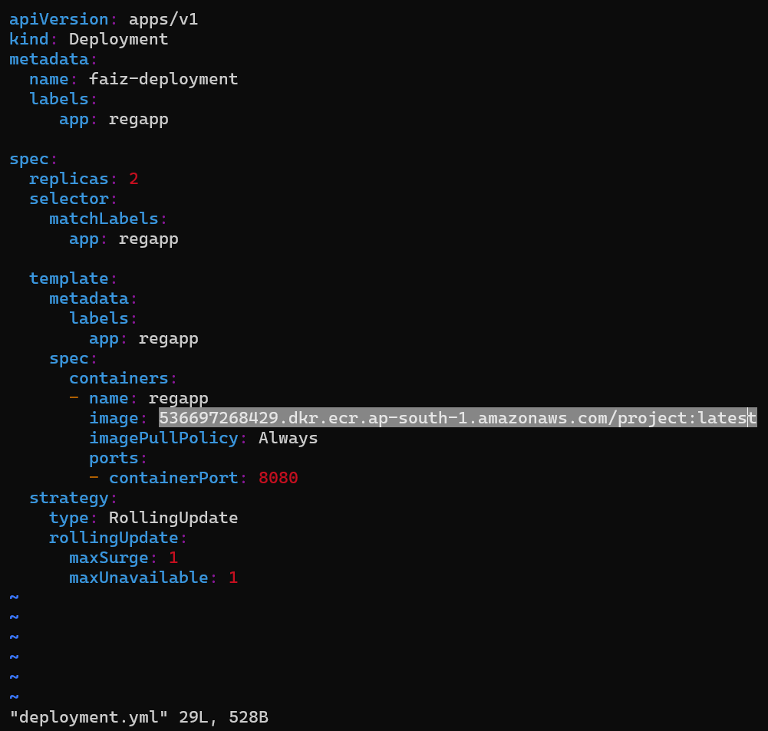



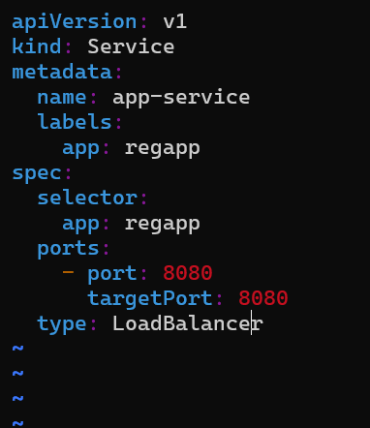

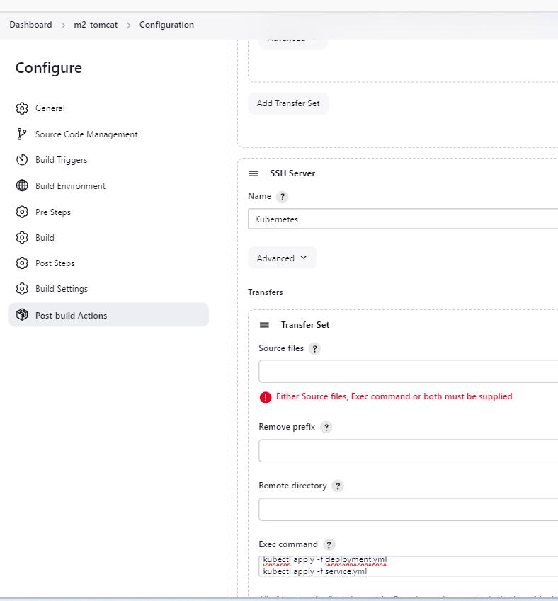

**Exec command:**

cd /scripts

kubectl apply -f deployment.yml

kubectl apply -f service.yml

**For Automation:**

